INDIVIDUAL TECHNICAL ARTEFACT REPORT
GNS3/Zeek Practical Network Dataset Engineering and Three-Stage Evaluation of Unsupervised Network Anomaly Detection

Project: Explainable and False-Positive-Aware Hybrid Unsupervised Network Anomaly Detection for Australian SME Financial Services

Unit: COIT20265 Networks and Information Security Project
CQUniversity, Australia
Term 2, 2026
Student: Arjita Saha
Student ID: 12297751

Table of Contents
1. Executive Summary 4
2. Introduction 5
2.1 Background 5
2.2 Problem Definition 5
2.3 Purpose and Scope 5
2.4 Individual Artefact Contribution 6
2.5 Artefact Objectives 6
2.6 Literature Review and Design Rationale 6
3. Requirements Analysis 8
3.1 Network, Stakeholder and Security Requirements 8
4. Technology Selection and Implementation Provenance 9
4.1 GNS3 and VMware 9
4.2 Zeek 9
4.3 PCAP and CICFlowMeter Context 9
4.4 Linux Platforms 9
4.5 Model and Code Implementation Provenance 9
4.6 Implementation Notebooks and Reproducibility 10
5. Test Environment Design and Network Architecture 11
5.1 Logical and Virtual Architecture 11
5.2 Network Isolation and Safety Controls 12
5.3 Monitoring Architecture 14
6. System and Sensor Configuration 15
6.1 Ubuntu Client and Server Configuration 15
6.2 Kali Linux Attacker Configuration 17
6.3 Zeek Installation, Interface Selection and Logging 17
6.4 Packet Visibility Verification 20
7. Traffic Generation and Evidence Collection 22
7.1 Experimental Design 22
7.2 Normal Traffic 22
7.3 Attack and Anomaly Traffic 24
8. Practical Dataset Construction and Raw Data Processing 27
8.1 Dataset Evolution: 27
8.2 Raw TSV Schema and Metadata Separation 28
8.3 Cleaning and Standardization 29
8.4 Direct Flow Features 29
8.5 Recent-Connection Behaviour Features 29
8.6 Protocol, Service and Zeek-to-UNSW State Mapping 30
8.7 From 21 Portable Features to 41 Model-Ready Features 30
8.8 Labelling and Metadata 31
8.9 Final Data-Quality Checks 31
9. Model Integration and Evaluation Methodology 31
9.1 Frozen Model Integration 31
9.2 Anomaly Scores 32
9.3 Hybrid IF+AE Fusion 32
9.4 Evaluation Metrics 32
9.5 Three-Stage Evaluation Design 32
10. Three-Stage GNS3/Zeek Evaluation and Results 33
10.1 Experiment 1 — Frozen UNSW Thresholds on Final Practical v5 33
10.2 Experiment 2 — GNS3 Normal-Only Threshold Recalibration 35
10.3 Experiment 3 — Six-Budget Threshold Sensitivity 36
10.4 Per-Traffic-Scenario Results at the 1% Reference Point 38
10.5 Source-Wise Results 39
11. Technical Findings, Verification and Quality Assurance 40
11.1 Why the Three Experiments Are Necessary Together 40
11.2 False-Positive Behaviour as an Operational Constraint 40
11.3 Calibration Budget Is Not a Held-Out FPR Guarantee 40
11.4 Hybrid Score Saturation 41
11.5 Dataset and Feature-Engineering Validity Checks 41
12. Ethical, Legal and Professional Considerations 41
12.1 Authorised Attack Simulation 41
12.2 Privacy and Data Minimization 41
12.3 Professional Integrity and Transparent Reporting 41
12.4 Intellectual Property and Code Attribution 42
12.5 Human Oversight and Decision Risk 42
13. Limitations, Risks and Recommendations 42
13.1 Technical Limitations 42
13.2 Future Experiment: Representative Normal Calibration 43
14. Conclusion 43
15. References 43
16. Appendices 45
Appendix A. Exact Final Dataset Composition 45
Appendix B. Exact 41-Feature Model Input 45
Appendix C. Full GNS3 Threshold-Budget Sweep 46
Appendix D. Screenshot and Evidence Placement Register 48
Appendix E. Artefact Output Files 48

1. Executive Summary
This individual technical artefact focuses on a practical problem in machine-learning network intrusion detection. A detector may work well on a benchmark dataset but behave very differently when the same learned feature patterns and numeric thresholds are used on traffic from another network. Recent studies show that normal traffic patterns can differ greatly between benchmark datasets and real networks. They also show that system performance can drop or vary across environments when new traffic does not match the training data (Layeghy and Portmann, 2023; Layeghy, Baktashmotlagh and Portmann, 2023; Layeghy, Gallagher and Portmann, 2024). For this reason, this artefact focuses on practical evidence, clear data processing and false-positive-aware testing instead of relying only on benchmark accuracy.

A controlled GNS3/VMware lab was built with an Ubuntu client, an Ubuntu server, a Kali Linux attacker and a passive Zeek sensor on an isolated 192.168.10.0/24 network. Normal HTTP, DNS, SSH and ICMP traffic was generated together with controlled attack or anomaly scenarios. These included Nmap scanning, DNS and HTTP bursts, HTTP probing, failed SSH login attempts, ICMP and UDP bursts, and bulk-transfer or exfiltration-like traffic. Zeek logs and PCAP files were saved as evidence. This follows the evidence-based dataset design used in recent Zeek cyber-range research, where packet data, logs and experiment records are kept so labels can later be checked (Bagui et al., 2023).

The practical dataset was expanded after the first version showed an important weakness. The original internal and external collection had 3,047 records but only 16 normal records. Two new sessions were therefore added. The v3 session contained 1,974 records, including 792 normal records, and the v4 session contained 1,945 normal-only records. The final v5 dataset contains 6,966 records: 2,753 normal and 4,213 attack records.

The raw Zeek connection records were cleaned and converted through a clear processing pipeline so they could be used by the existing models. Fifteen raw and source-information columns were checked. Thirteen network fields were converted into 21 portable features. Recent-connection count features were calculated from the current record and up to 99 earlier records within each captured source and scenario session. The saved preprocessor was applied only to transform the practical data; it was not fitted again. The final model matrix has 6,966 rows and 41 numeric features, with no NaN or infinite values. This design keeps model testing separate from target-data retraining and provides a clear path from generated traffic to final model input.

Three GNS3/Zeek testing stages were completed with six frozen detectors. First, the original UNSW-based thresholds were applied unchanged to all 6,966 practical records. All six models flagged almost every normal record, giving false-positive rates close to 99%. This showed that the source thresholds did not transfer well to the practical network. Second, the model weights remained unchanged, but new thresholds were calculated from normal records. At the 1% calibration budget, Deep SVDD achieved a held-out FPR of 1.73% with 24.35% recall, while Isolation Forest achieved 59.22% recall with 7.92% FPR. Third, thresholds were tested at six budgets: 0.5%, 1%, 2%, 3%, 5% and 10%. This showed different trade-offs for different models. Deep SVDD changed strongly between 2% and 3%, reaching 64.68% recall, 98.70% precision.

The main contribution is not a claim that one model is always the best. Instead, the artefact provides a clear and checkable evaluation showing that practical system performance depends on the source of the data, the normal traffic used for calibration, the score distribution, the chosen threshold and the range of traffic scenarios.

2. Introduction

2.1 Background
Anomaly-based detection is useful when there are not enough labelled attack examples for training. The system checks network traffic and gives each event an anomaly score to show how unusual it is. However, a threshold is still needed to decide when an unusual event should be treated as an alert. If the threshold is too sensitive, normal network activity may also be flagged, which can create too many false alerts. Goldschmidt and Chudá (2025) explain that system performance is affected by the quality of the dataset, differences between data sources and the way traffic is collected. Pinto et al. (2025) also show that the way network traffic is captured and prepared can directly affect the final detection results. This is important for small financial services organizations, because too many false alerts can make security monitoring difficult and waste analysts’ time.

Zeek was chosen as the main monitoring and evidence tool because it turns network packets into structured connection and application logs while keeping a clear link to the original traffic. The Book of Zeek explains that conn.log record types of connection activity, while standard logs provide protocol-specific details (Zeek Project, 2026a; 2026b). Recent studies have also used Zeek logs to build intrusion-detection datasets and to support anomaly detection (Bagui et al., 2023; Moomtaheen et al., 2024). Therefore, Zeek was suitable both for observing the controlled lab traffic and for creating the data used in the machine-learning evaluation.

2.2 Problem Definition
The problem addressed by this artefact is: how can a practical, repeatable and safely isolated Zeek-based network dataset be created to test whether unsupervised anomaly-detection models trained on UNSW-NB15 still work usefully in a different network environment, while also measuring and controlling false-positive alerts?

The problem has four connected parts. First, the lab must generate repeatable normal and attack traffic without sending harmful traffic to systems outside the project.
Second, the captured packet and log data must be converted into features that match the models, without fitting the models again on the target data or giving them label information.
Third, the evaluation must separate the quality of the anomaly scores from the choice of threshold. Otherwise, a model that still ranks attacks above normal traffic may appear useless simply because its threshold came from another dataset.
Fourth, the analysis must examine false alerts, differences between capture sessions and uncertainty from very small scenario samples instead of relying only on F1-score.

2.3 Purpose and Scope
This report documents the full practical artefact from building the network to explaining the final test results. It covers internal and external practical traffic sources, Zeek and PCAP evidence, raw TSV creation, data cleaning, labelling, 21-feature engineering, conversion to 41 model-ready features, quality checks, integration of the frozen models and the three GNS3/Zeek testing stages.

2.4 Individual Artefact Contribution
Table 2.1. Individual contribution and dependency boundary
Contribution | What was completed
Practical testbed | GNS3/VMware topology, addressing, endpoint roles, isolation, Zeek sensor and packet visibility.
Traffic generation | Normal and controlled attack/anomaly scenarios with easy to trace source, scenario and time context.
Dataset engineering | Internal/external merge, version expansion, raw cleaning, labels, 21 portable features, saved preprocessor transform to 41 features.
Practical evaluation | Original frozen thresholds; target normal-only recalibration; six-budget threshold sweep; scenario/source analysis.
Six trained models | Loaded as frozen team artefacts. No claim is made that this artefact trained or invented the models.

2.5 Artefact Objectives
- Build an isolated network where normal and malicious traffic can be generated without unauthorised scanning or attack traffic leaving the lab.
- Save packet-level evidence and Zeek logs so each practical dataset record can be linked back to an observed network event and capture session.
- Build a practical dataset that fixes the original problem of having only 16 normal records and keeps clear source and scenario information.
- Convert Zeek traffic into the exact 41-feature format required by the frozen models without fitting the preprocessor again on the target data.
- Test six detectors using the original source thresholds, then study threshold recalibration using only normal traffic from the target environment while keeping the model weights unchanged.
- Test threshold sensitivity at 0.5%, 1%, 2%, 3%, 5% and 10% budgets and report Precision, Recall, F1, FPR, ROC-AUC, PR-AUC and false alerts per 1,000 normal records.
- Explain important practical problems, including differences between data sources, score saturation, traffic types that are missed and unstable results caused by very small samples, and suggest suitable improvements.

2.6 Literature Review and Design Rationale
Recent research shows that creating and preparing a practical network dataset is an important part of NIDS research, not just a small testing step. Bagui et al. (2023) created the UWF-ZeekData22 dataset in a cyber range and kept both Zeek logs and PCAP files together with experiment information. This made it easier to check how the traffic was created and how the labels were assigned.
Lanfer, Brockmann and Aschenbruck (2025) also explain that anomaly-based NIDS need datasets that are correctly labelled, realistic and varied. Their WEB-IDS23 dataset includes both normal and malicious traffic. Goldschmidt and Chudá (2025), after reviewing many public NIDS datasets, found that dataset quality, differences between network environments and data-processing choices can strongly affect evaluation results. These studies support the approach used in this artefact, where traffic source, scenario type and capture session are kept separately, while labels and other ground-truth information are not used as model features.
A major challenge for this project is cross-domain distribution shift. Layeghy, Gallagher and Portmann (2024) found substantial differences between normal traffic represented in synthetic benchmark datasets and traffic collected from real production networks. Layeghy and Portmann (2023) also showed that the performance of machine-learning-based NIDS can decline when a model is evaluated on a network environment that differs from the one used for training. Similarly, Layeghy, Baktashmotlagh and Portmann (2023) identify domain shift as an important limitation in machine-learning intrusion detection
Distribution changes can also occur between different time periods or capture sessions within the same general environment. Dragoi et al. (2022) demonstrate through the benchmark that unsupervised anomaly-detection performance can change when normal data behaviour changes over time. This means that a model may continue to produce meaningful anomaly rankings while its original decision threshold becomes unsuitable for new traffic.
The selection of Zeek as the monitoring and evidence platform is also supported by recent research. Moomtaheen et al. (2024) use Zeek connection data with an Isolation Forest-based intrusion-detection approach, demonstrating that structured Zeek logs can provide useful information for machine-learning analysis. Zeek records connection timing, endpoints, ports, protocol, service, duration, packet counts, byte counts and connection state, which provides a practical basis for creating flow-level features. In this project, conn.log is therefore used as the main raw source for feature engineering, while protocol-specific logs and PCAP files provide additional evidence that the expected network activity occurred.
Borgioli et al. (2024) demonstrate that autoencoder reconstruction error can be used to identify unusual network behaviour without requiring labelled attack examples during the anomaly-learning process. This is relevant to the project because the aim is not simply to classify known attacks, but to investigate whether models trained to recognise normal or unusual patterns can still provide useful anomaly scores when applied to independently generated practical traffic.
Sun, Sankararaman and Narayanaswamy (2024) examine adaptive anomaly-threshold selection and show why a fixed threshold may not remain appropriate when observations shift over time or between environments. A threshold that is effective on one dataset may generate excessive false positives or miss attacks when transferred to another. This provides the main rationale for the three-stage evaluation used in this artefact: first testing the original UNSW-based thresholds, then recalibrating thresholds using normal-only practical GNS3 traffic and finally evaluating several false-positive budgets. The literature therefore supports both the practical dataset-engineering approach and the decision to treat threshold behaviour, false-positive control and domain shift as central parts of the evaluation rather than focusing only on benchmark accuracy.
Table 2.2. Literature-to-design traceability
Literature finding | How this artefact responds
Dataset source information and realistic capture matter (Bagui et al., 2023; Goldschmidt and Chudá, 2025). | Keep raw logs/PCAP, data_source, traffic_type, timestamps and version history.
Representative benign traffic is necessary (Lanfer, Brockmann and Aschenbruck, 2025). | Expand normal traffic from 16 records to 2,753 and create a dedicated normal calibration session.
Benchmark and real traffic distributions differ (Layeghy, Gallagher and Portmann, 2024). | Evaluate frozen models on independently generated GNS3/Zeek traffic.
Cross-domain performance can collapse (Layeghy and Portmann, 2023; Layeghy, Baktashmotlagh and Portmann, 2023). | Separate source-threshold transfer from target-normal recalibration.
Thresholds are practical parameters under shift (Sun, Sankararaman and Narayanaswamy, 2024). | Sweep six normal-only budgets and evaluate actual held-out FPR.
Zeek logs support ML intrusion analysis (Moomtaheen et al., 2024). | Use conn/http/dns/ssh logs as structured evidence and raw feature source.

3. Requirements Analysis

3.1 Network, Stakeholder and Security Requirements
The network had to be safe, easy to monitor and able to produce the same type of traffic again when needed. The dataset also needed to keep clear information about where the traffic came from and be converted into the format required by the models. The testing needed to show false alerts clearly so that the results could be understood and checked by others. The main stakeholders are the project team, the supervisor and assessors, and the SME security staff who may use the alerts in a real environment.
Table 3.1. Requirements and verification evidence
ID | Requirement | How it is checked
R1 | Isolate attack-generation traffic from unrelated systems. | Private VMware/GNS3 segment, topology screenshots and reachability tests.
R2 | Provide passive traffic visibility for the monitoring sensor. | Zeek interface/IP evidence plus known-flow capture in conn.log.
R3 | Generate repeatable benign HTTP, DNS, SSH and ICMP traffic. | Client/server command evidence and protocol logs.
R4 | Generate controlled anomaly/attack scenarios without third-party targets. | Kali command evidence, scenario labels and PCAP/log timestamps.
R5 | Preserve packet and structured-log evidence. | PCAP plus conn.log/dns.log/http.log/ssh.log archives.
R6 | Maintain internal/external/source-session source information. | data_source and traffic_type fields in raw/metadata files.
R7 | Produce exactly 41 numerical model-ready features without target refit. | Saved UNSW preprocessor, shape assertion 6,966×41, finite-value checks.
R8 | Evaluate six frozen models consistently. | Common score orientation, threshold rule and metrics.
R9 | Separate calibration normals from held-out testing. | v4 calibration index vs 5,021-record separate test set.
R10 | Measure false alert/detection trade-offs at multiple budgets. | 0.5/1/2/3/5/10% sweep CSV/XLSX and charts.
R11 | Keep enough evidence to reproduce each stage. | Notebooks, thresholds JSON, result CSV/XLSX, charts and screenshot.

4. Technology Selection and Implementation Provenance

4.1 GNS3 and VMware
GNS3 was chosen because it can build controlled virtual network topologies and connect directly to VMware virtual machines. This allowed the Ubuntu and Kali operating systems to take part in the same lab network. GNS3 documentation supports VMware-based VMs and describes safe pre-deployment testing as one of its main uses (GNS3, 2026a; 2026b). VMware provided the isolated virtual network and stable networking needed to keep endpoint addresses consistent. This combination was more suitable than using only a synthetic packet generator because the artifact needed real Linux network stacks, real service behaviour and connection states that Zeek could observe.

4.2 Zeek
Zeek is the main network monitoring sensor in this artifact. Its conn.log records connection timing, source and destination addresses and ports, protocol, duration, packet and byte counts, and connection state. Zeek also provides protocol logs that closely match the information needed for practical feature engineering, without depending only on packet payload inspection. Zeek is used passively: it watches and records the traffic but does not block it. This keeps the experiment focused on detection rather than prevention.

4.3 PCAP and CICFlowMeter Context
PCAP files were kept as a lower-level evidence source because they allow a capture session to be checked. CICFlowMeter was also considered as a supporting flow-generation tool. The University of New Brunswick explains that CICFlowMeter creates bidirectional flows and more than 80 statistical features, including duration, packet counts and byte measures (UNB CIC, 2026). Raw fields from Zeek were converted through the project's own feature-engineering steps into the portable UNSW-compatible format. Making this difference clear improves repeatability and avoids giving the wrong source for the features.

4.4 Linux Platforms
Ubuntu was used for the client, server and Zeek sensor because it provides reliable networking tools and common service packages. Kali Linux was used only as an authorised attack-generation machine. Giving the normal client and attack machine separate roles makes the traffic easier to label and check later.

4.5 Model and Code Implementation Provenance
Google Colab was used to process the practical Zeek data and run the testing notebooks. The main work in this artefact included cleaning raw Zeek records, creating portable network features, converting them into the 41-feature format required by the saved preprocessing pipeline, loading the previously trained models, recalibrating thresholds, and calculating evaluation results. The main software tools and code sources are listed below.

Table 4.1. Implementation provenance
Component | How it was used in this artefact | Source to cite
Zeek raw-data processing | Read and clean connection information such as protocol, service, duration, bytes, packets and connection state. | https://github.com/zeek/zeek  Zeek Project (2026a–c)
Feature conversion | Converted raw Zeek records into 21 portable features and then into the final 41 model-ready features using the saved preprocessing pipeline. | https://github.com/numpy/numpy  https://github.com/pandas-dev/pandas  NumPy Developers (2026)
Six previously trained models | Models were loaded only for practical testing. This artifact did not train the models. Their anomaly scores were used for thresholding and evaluation. | https://github.com/scikit-learn/scikit-learn/blob/main/doc/modules/outlier_detection.rst Scikit-learn Developers (2026a–c)
Threshold recalibration | Used labelled-normal practical traffic to calculate target-domain thresholds at 0.5%, 1%, 2%, 3%, 5% and 10% false-positive budgets. | https://numpy.org/doc/stable/reference/generated/numpy.quantile.html  NumPy Developers (2026); Sun, Sankararaman and Narayanaswamy (2024)
Evaluation metrics | Calculated Precision, Recall, F1-score, False Positive Rate, ROC-AUC, PR-AUC and confusion matrices. | https://scikit-learn.org/stable/modules/model_evaluation.html  https://github.com/scikit-learn/scikit-learn Scikit-learn Developers (2026)
Result generation | Exported model comparisons, scenario-level results, source-level results and threshold-sweep outputs as CSV, Excel and charts. | https://github.com/matplotlib/matplotlib Matplotlib Developers (2026)

4.6 Implementation Notebooks and Reproducibility
The following Google Colab notebooks contain the implementation used for practical dataset processing and model evaluation.
- Dataset preprocessing and feature conversion: https://colab.research.google.com/drive/1qW0VUimTsEQOPwHnigX-GYFDBCvBWG5r?usp=sharing
- Frozen-threshold model evaluation: https://colab.research.google.com/drive/1qjV0nN_zNA1TELHNI_4TFkfvdtpCKU6U?usp=sharing
- Normal-only threshold recalibration: https://colab.research.google.com/drive/1bjsNLPJi9aswA4_D7d0ypdM33m5NNMcm?usp=sharing
- Threshold-budget sensitivity analysis: https://colab.research.google.com/drive/1L7F0FfdmxOHJM5n3gvjJbDWuhEGEJvEK?usp=sharing

5. Test Environment Design and Network Architecture

5.1 Logical and Virtual Architecture
The lab uses a small topology because the purpose is to create clear, traceable traffic and study anomaly scores, not to copy a full enterprise network. The main subnet is 192.168.10.0/24. The Ubuntu client (192.168.10.10) creates normal user traffic, the Ubuntu server (192.168.10.20) provides controlled services, the internal Kali attacker (192.168.10.30) creates authorized attacks or abnormal traffic, and the Zeek sensor watches the network. External-laptop (192.168.4.52) traffic is kept under the separate external laptop source label so it can be analyzed separately instead of being mixed with the internal captures.

Table 5.1. Practical network roles and addressing
Node / source | Address / identifier | Role | Why it is used
Ubuntu client | 192.168.10.10 | Normal client | Generate routine HTTP/DNS/SSH/ICMP interactions.
Ubuntu server | 192.168.10.20 | Controlled target/service host | Receive normal and authorised attack traffic.
Kali attacker (internal) | 192.168.10.30 | Attack generator | Nmap/burst/probing/failed-auth scenarios inside isolated lab.
Zeek sensor | Passive interface on lab segment | Monitoring/evidence | Observe traffic without becoming an inline enforcement point.
External laptop/Kali source | 192.168.4.52 | Additional practical domain | Increase source diversity; analysed separately because normal denominator is small.

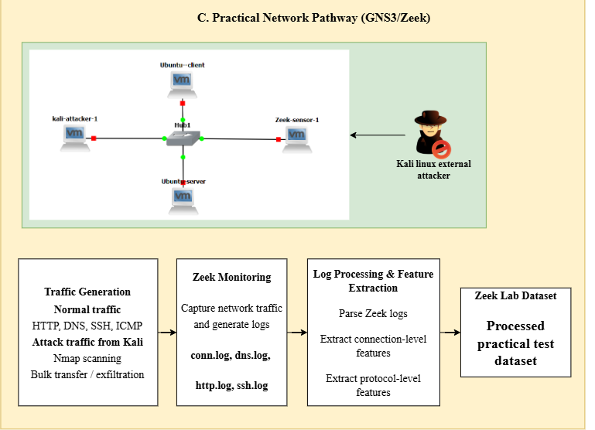
Figure 5.1. Practical GNS3/Zeek pathway used for controlled traffic generation, monitoring, feature extraction and practical testing.

5.2 Network Isolation and Safety Controls
Attack traffic was kept inside project-controlled systems. The private VM network reduces the chance of accidental exposure, and all testing commands were sent to specific lab IP addresses. Zeek remained a passive sensor, so it did not change the normal or attack traffic being measured. This isolation improves both safety and experiment quality: the endpoints are known, unrelated background traffic is reduced, and captured events can be linked more confidently to the scenario that was running.
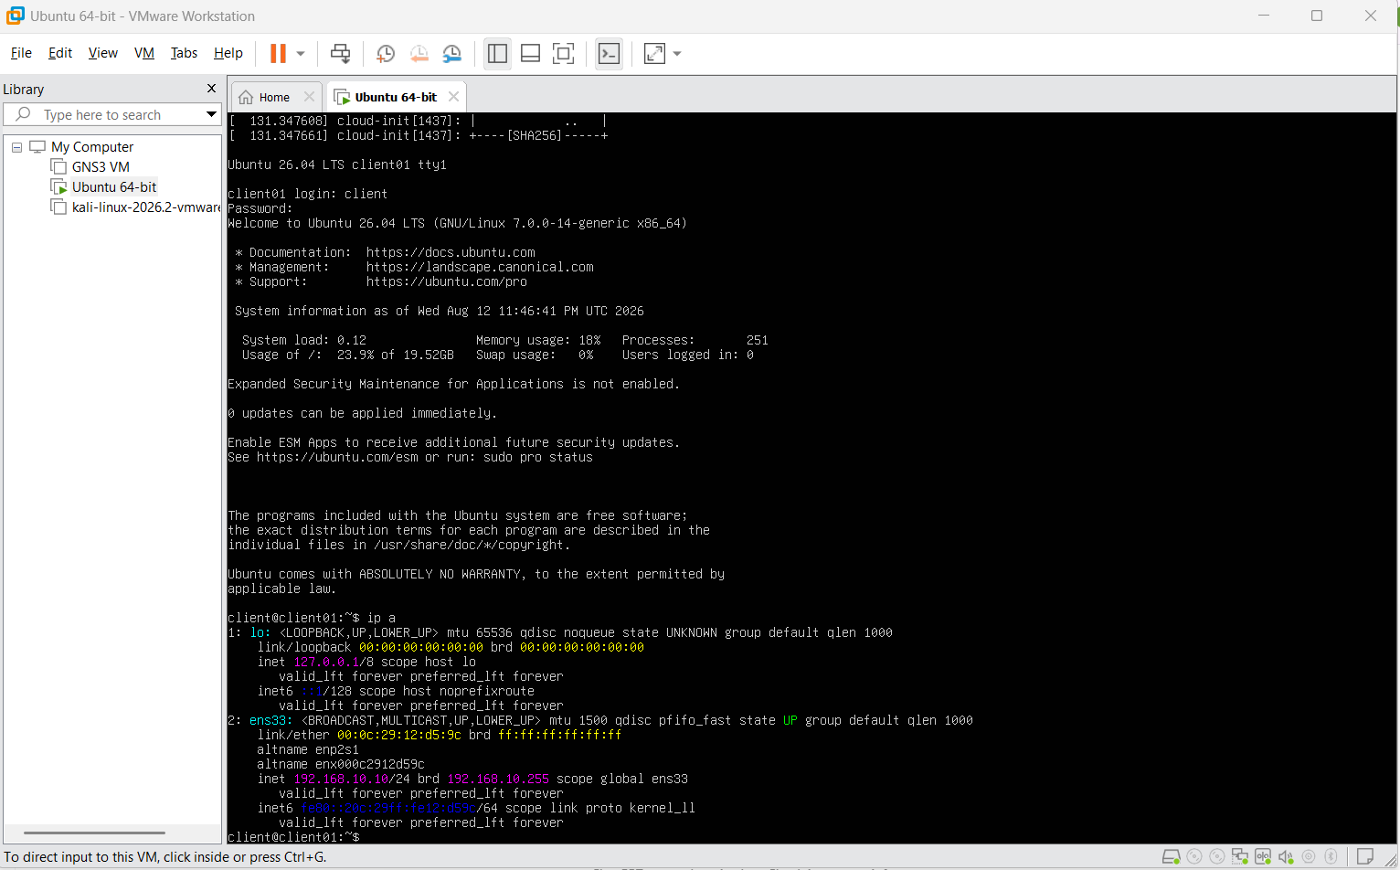
Figure 5.2. Ubuntu client static address configuration on the isolated 192.168.10.0/24 lab network.
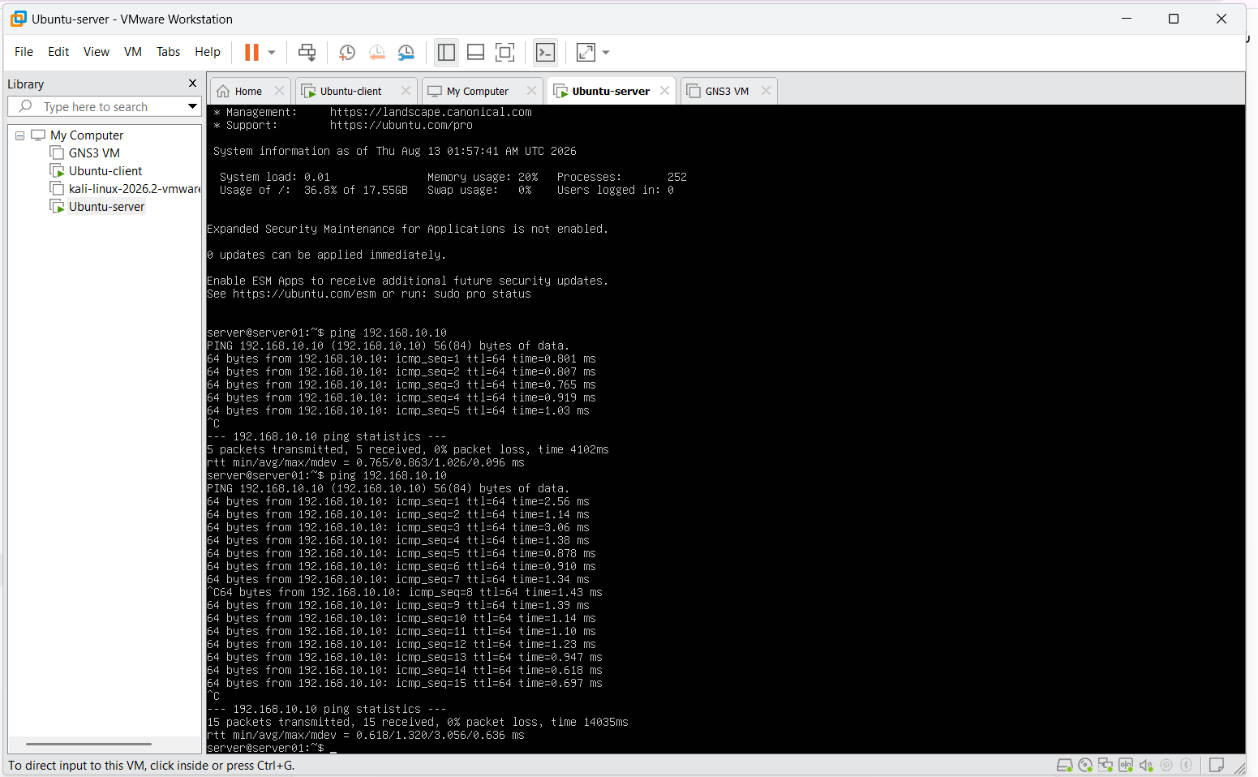
Figure 5.3. Client-to-server ICMP reachability verification between 192.168.10.10 and 192.168.10.20

5.3 Monitoring Architecture
The monitoring design keeps two useful evidence sources. PCAP stores the original packets so a session can be checked again later, while Zeek creates structured connection and protocol logs that are easier to convert into flow features. Recent Zeek cyber-range research has used the same general approach by keeping both packet captures and Zeek logs to support later checking and labelling (Bagui et al., 2023). Conn.log is the main raw source for feature creation; other specific logs are used to confirm that the expected application traffic was seen.
External routed validation path
The internal 192.168.10.0/24 attack lab remained the main isolated environment, but a separate controlled route was enabled to test source diversity. The external laptop/Kali source at 192.168.4.52 reached only the project Ubuntu server at 192.168.10.20 through the host/VMnet4 path. The server return route for 192.168.4.0/22 used 192.168.10.1, and packet capture was used to verify the path before external test traffic was collected. This was a controlled project path rather than unrestricted scanning of unrelated systems.
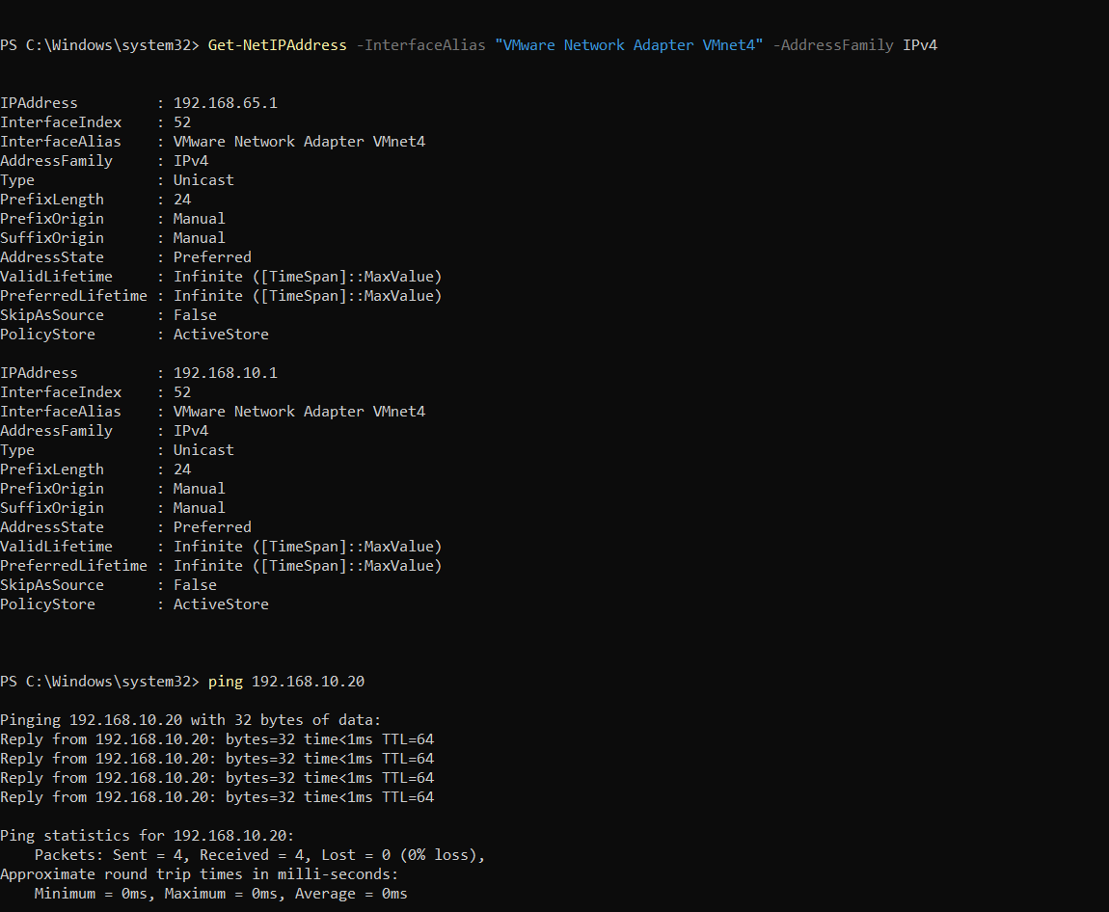
Figure 5.4. External-to-lab routing verification showing the server return route via 192.168.10.1 and captured ICMP traffic from 192.168.4.52.
External captures were preserved and processed separately from the internal GNS3 sessions. PCAPs for external normal, Nmap, HTTP burst, DNS burst, failed-SSH and ICMP scenarios were processed with Zeek into scenario-specific logs and retained under the external laptop source label.
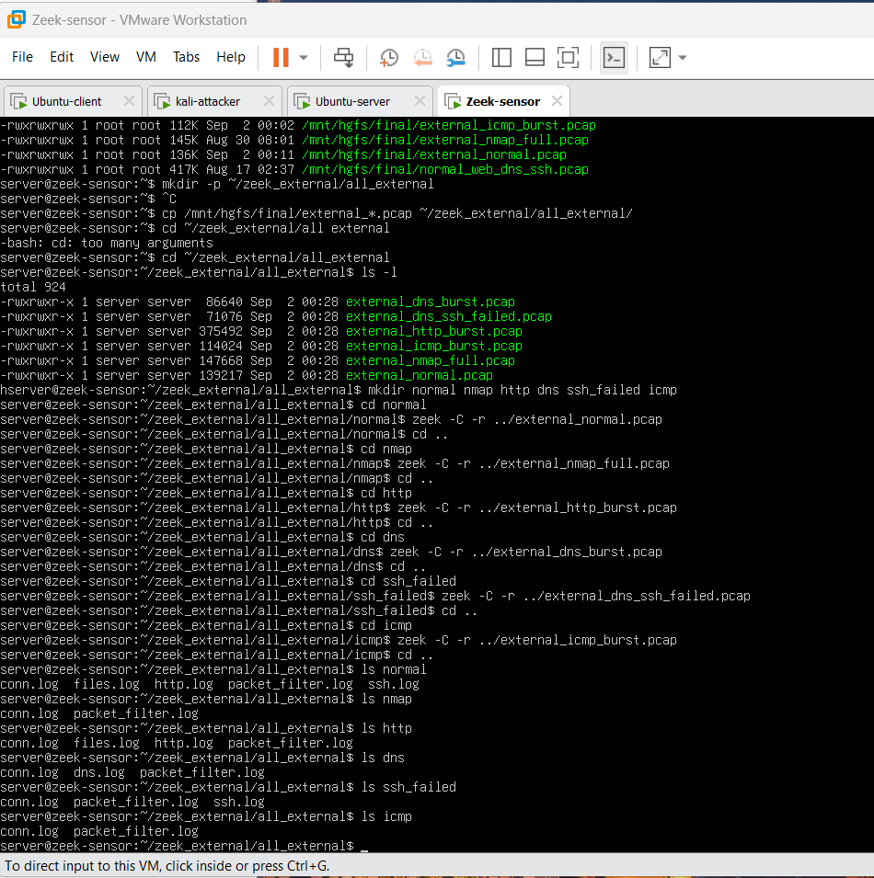
Figure 5.5. Separate processing of external-source PCAPs into scenario-specific Zeek logs before dataset merging.

6. System and Sensor Configuration

6.1 Ubuntu Client and Server Configuration
The Ubuntu client and server were given fixed IP addresses in the lab subnet, so their roles stayed the same across different capture sessions. The server ran the services needed for normal traffic and selected attack scenarios. Before collecting any dataset traffic, connectivity and service responses were checked. This made it easier to tell whether a missing Zeek log entry was caused by a monitoring problem or by a service that was not working.
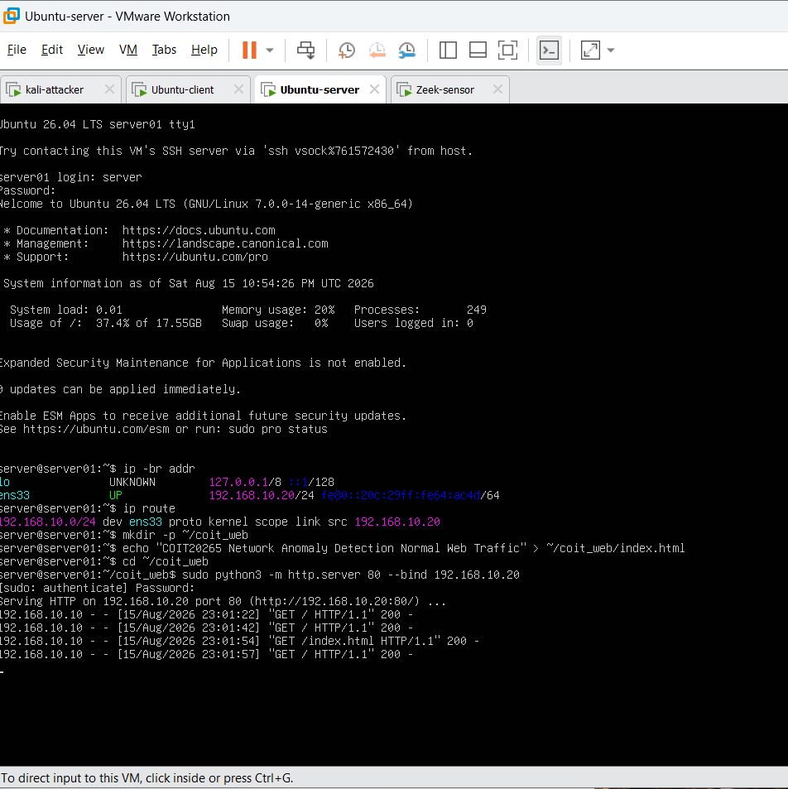
Figure 6.1. Ubuntu server HTTP service configuration and successful normal web requests from the client.
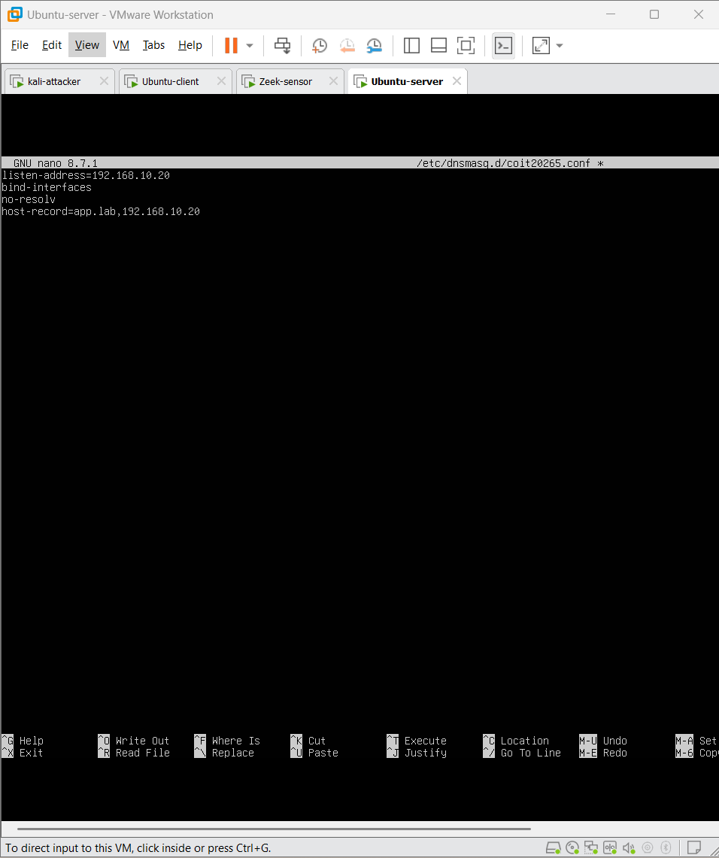
Figure 6.2. Controlled DNS service configuration for app.lab on the Ubuntu server.

6.2 Kali Linux Attacker Configuration
Kali was set up as a dedicated attack-generation machine rather than a normal user device. Keeping attack traffic separate from the Ubuntu client makes labels easier to trust and allows the kali_source metadata flag to be created without giving that information to the model. All attack commands were sent only to project-controlled targets. Traffic generated from an external laptop was also stored under its own source label so its behaviour could be analysed separately instead of being assumed to match the internal lab traffic.

6.3 Zeek Installation, Interface Selection and Logging
Zeek was installed on the sensor and attached to the network interface that could see the lab traffic. The checking process was simple and repeatable: confirm the Zeek version, confirm the sensor address and interface, start live monitoring, generate one known connection, check that it appears in conn.log, and then check the related protocol log where needed. Zeek documentation supports both live-interface monitoring and offline PCAP analysis, and it describes conn.log as the main connection record (Zeek Project, 2026a; 2026c).

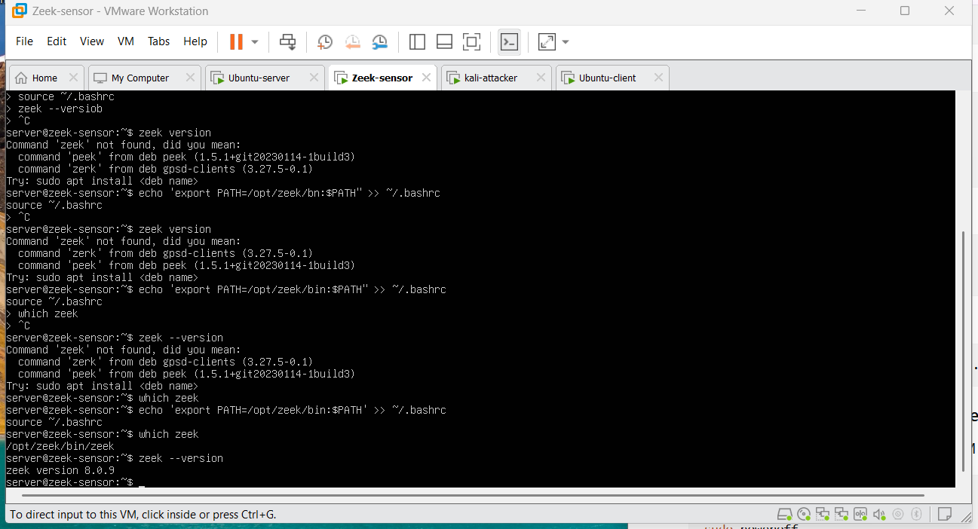
Figure 6.3. Zeek installation path and version verification on the monitoring sensor.
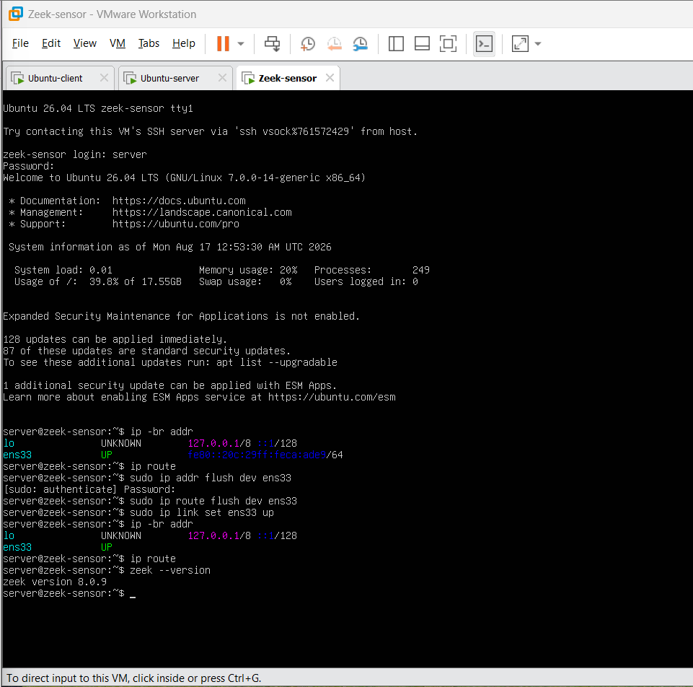
Figure 6.4. Zeek sensor interface verification and Zeek 8.0.9 version check.
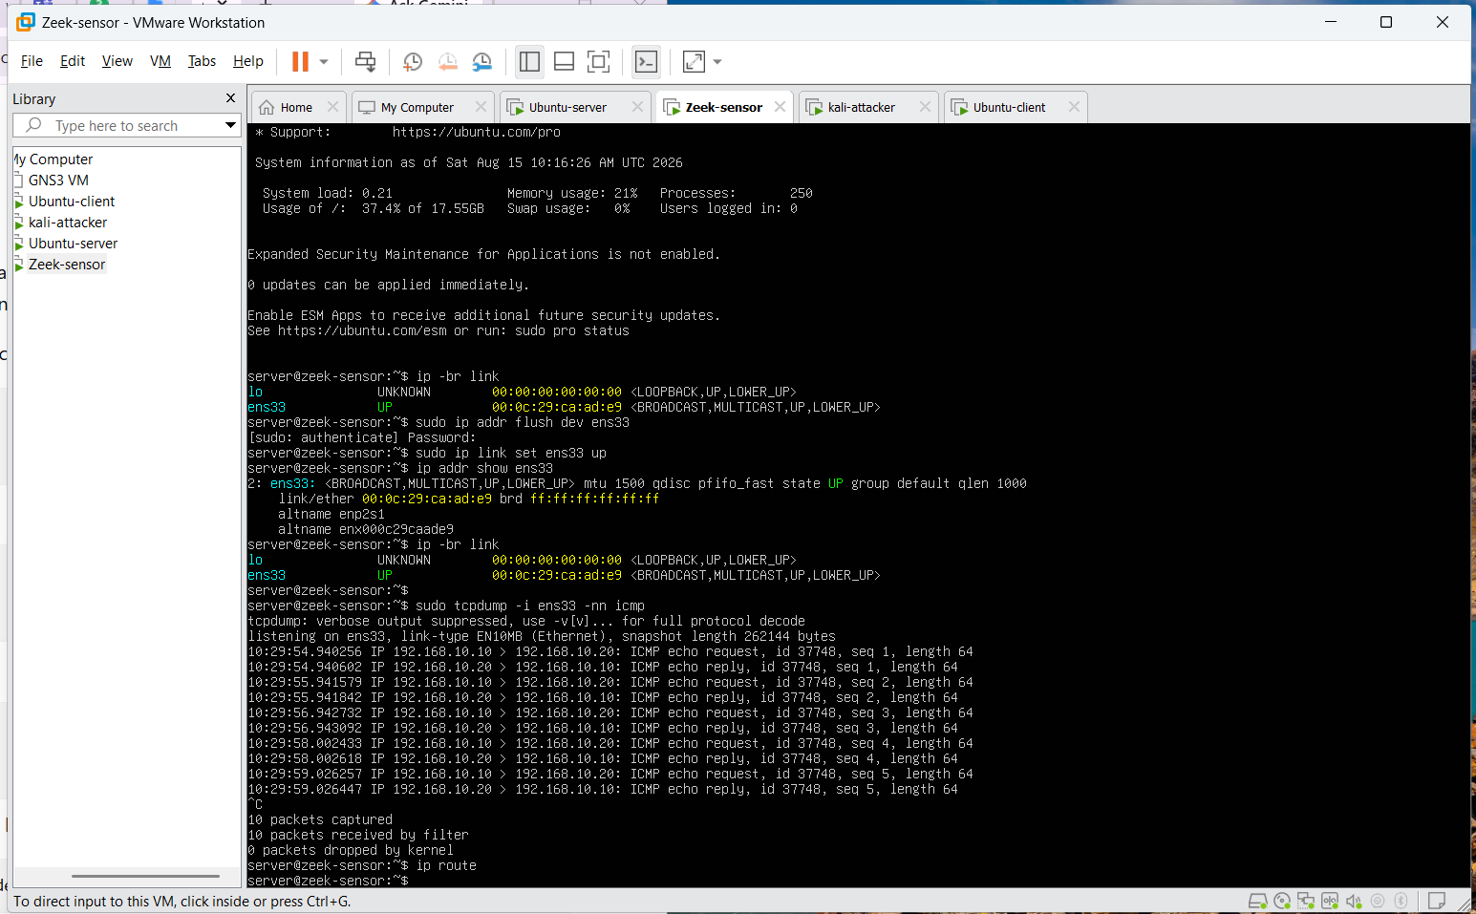
Figure 6.5. Packet-visibility verification on ens33 showing ICMP traffic between the client and server.
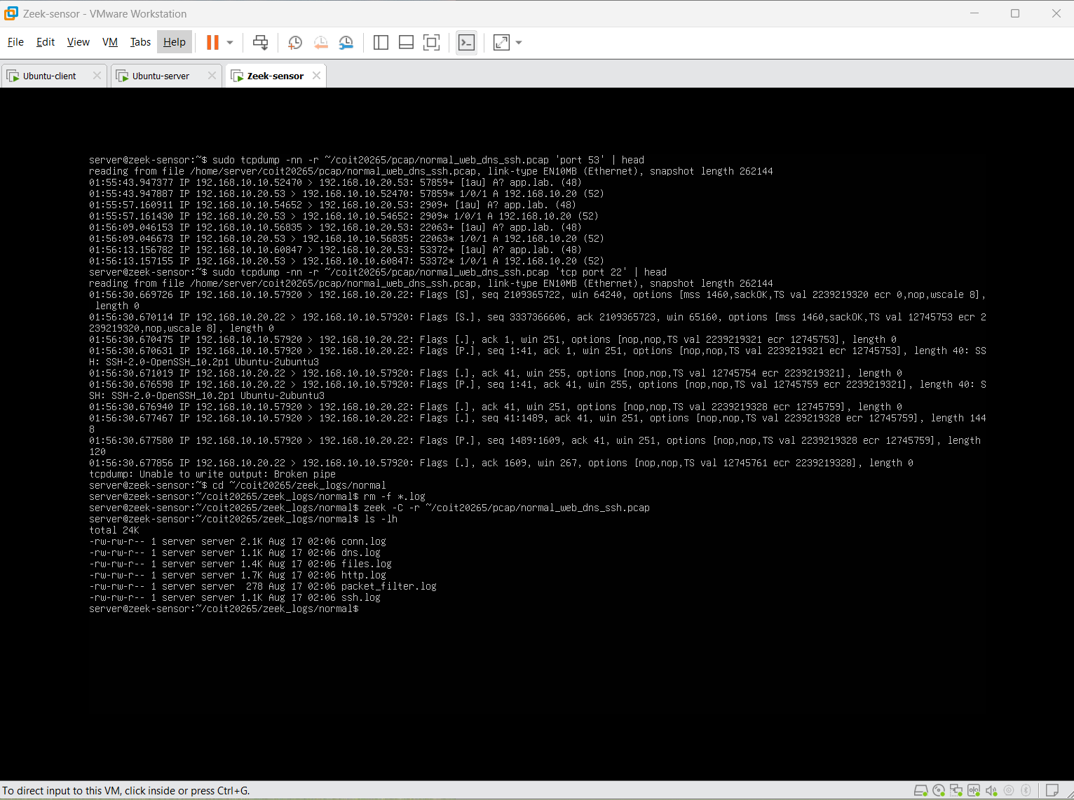
Figure 6.6. Offline PCAP inspection confirming normal DNS and SSH traffic before log processing
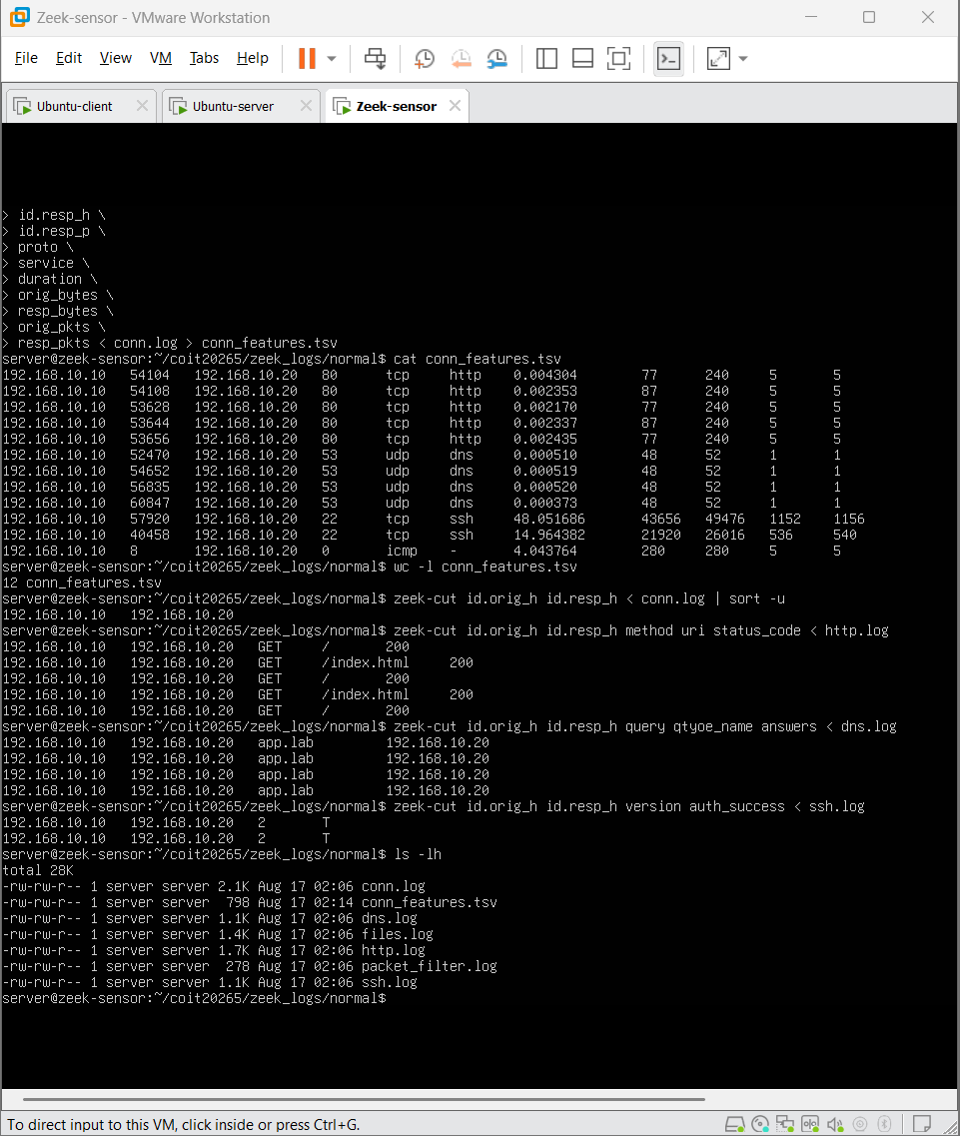
Figure 6.7. Zeek connection-feature extraction and protocol-log verification for normal traffic.

6.4 Packet Visibility Verification
Packet visibility was checked before large-scale data collection started. A known client-to-server connection was generated and then confirmed in three places: the endpoint command or response, the PCAP capture and the Zeek log. This three-part check reduces the risk of collecting traffic from the wrong interface without noticing. It also creates useful evidence if a later feature row does not match the scenario that was expected.
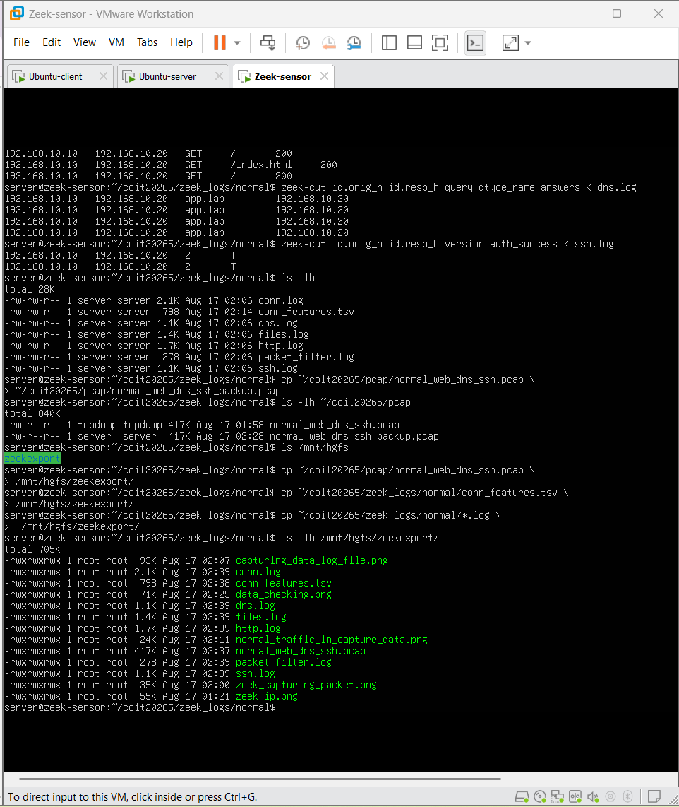
Figure 6.8. Preserved PCAP, conn.log, protocol logs and exported evidence files used for traceability.

7. Traffic Generation and Evidence Collection

7.1 Experimental Design
Traffic was generated in clearly identified scenarios instead of being collected as one mixed stream. This makes the data easier to trace because the expected hosts and protocols are known before each capture and can be checked against Zeek logs and PCAP files. It also makes later per-scenario testing possible.

7.2 Normal Traffic
Table 7.1. Normal traffic scenarios
Scenario | How it was generated and checked | Why it is included
HTTP | Client requests to the controlled server; validate response and `http.log`/`conn.log`. | Represents routine web/application exchanges and TCP request/response behaviour.
DNS | Client queries via the configured DNS path; validate query/answer and dns.log. | Represents short UDP request/response flows and a core enterprise dependency.
SSH | Successful interactive/session traffic to the controlled host; validate connection and ssh.log. | Provides encrypted management-style connections and longer-lived TCP behaviour.
ICMP | Controlled ping/echo requests between lab endpoints; validate response and conn.log. | Adds non-TCP/UDP network-control traffic and broadens normal protocol coverage.

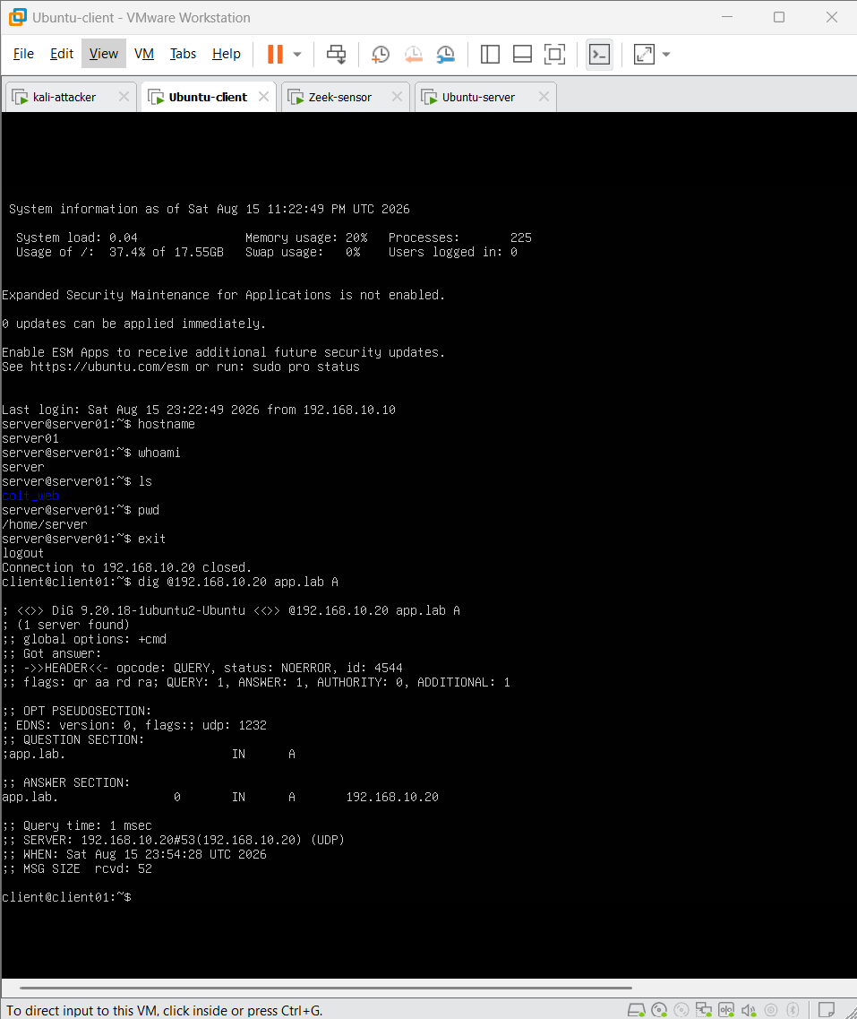
Figure 7.1. Successful normal DNS resolution for app.lab from the Ubuntu client.
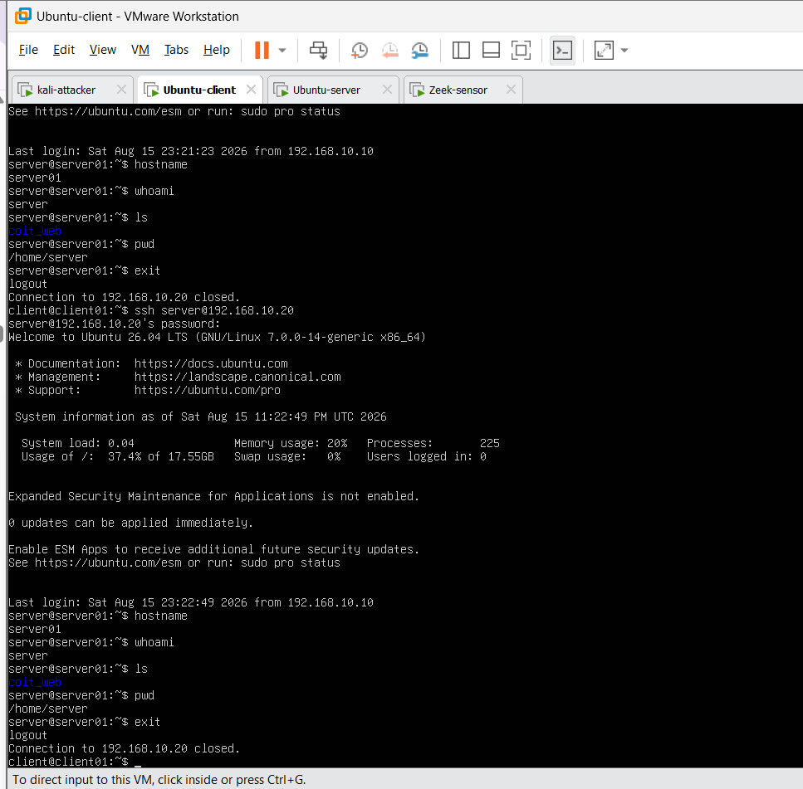
Figure 7.2. Successful SSH client-to-server session used as normal encrypted management traffic.

7.3 Attack and Anomaly Traffic
Attack and anomaly scenarios were chosen to create different types of unusual network behaviour rather than to cover every possible cyberattack. Reconnaissance creates many connection attempts, burst traffic creates unusual rates, failed SSH creates repeated authentication failures, and bulk transfer creates unusual traffic volume or duration. This variety matters because one detector may recognise one type of abnormal behaviour but miss another. Recent dataset-generation research also recommends using different protocols and attack types so that an evaluation is not based on only a narrow set of threats (Lanfer, Brockmann and Aschenbruck, 2025; Goldschmidt and Chudá, 2025).

Table 7.2. Attack/anomaly scenarios and final counts
Scenario | Final records | Expected network behaviour | Why this scenario was selected
Nmap scan | 3,061 | Many short/repeated connection attempts and destination-port variation. | Nmap scanning represents reconnaissance, where an attacker searches for open ports and available services before attempting further attacks. It is important for SMEs because exposed services can be discovered quickly and may become targets for unauthorised access.
DNS burst | 649 | High frequency of short DNS-oriented flows. | DNS is used by almost every business network, so unusual bursts can indicate automated activity, misconfiguration or malicious behaviour. This scenario helps test whether the system can detect abnormal repetition in a common network service.
HTTP burst | 411 | Repeated HTTP/TCP connections or requests. | HTTP is a normal business service, but a sudden burst of requests may indicate automated probing, abuse or denial-of-service style behaviour. It is important for SMEs because high request volumes may affect web services and can be difficult to distinguish from legitimate user activity.
HTTP probing | 60 | Small probing/reconnaissance-style HTTP set. | HTTP probing represents attempts to discover web pages, services or weaknesses before a larger attack. It is useful for testing whether the detector can recognise low-volume reconnaissance that may look similar to normal web traffic.
Failed SSH | 20 | Repeated failed authentication/SSH attempts. | Repeated failed SSH logins can represent password guessing or attempts to access remote administration services. This is important for SMEs because SSH is commonly used for system management and compromised credentials could provide direct access to servers.
UDP burst | 6 | Short high-rate UDP activity. | UDP bursts represent sudden increases in connectionless traffic and can be linked with flooding, scanning or abnormal application behaviour. This scenario adds protocol variety and tests whether the detector can recognise unusual UDP activity.
Bulk transfer / exfiltration-like | 3 | Large/long transfer relative to routine traffic. | Large data transfers can represent legitimate backup activity, but they can also indicate possible data exfiltration. This is especially relevant to financial-service SMEs because they handle sensitive customer and business information that could cause serious harm if transferred without authorisation.
ICMP burst | 3 | Repeated echo/control packets. | ICMP is normally used for troubleshooting and connectivity checks, but repeated ICMP traffic may indicate scanning, flooding or abnormal host activity. It is useful for testing whether the detector can identify unusual network-control traffic outside normal TCP and UDP behaviour.
Representative execution evidence for selected attack scenarios is shown below. Only distinct examples are included to avoid repeating similar terminal output for every scenario; the complete PCAP and Zeek log files remain part of the artefact evidence package.

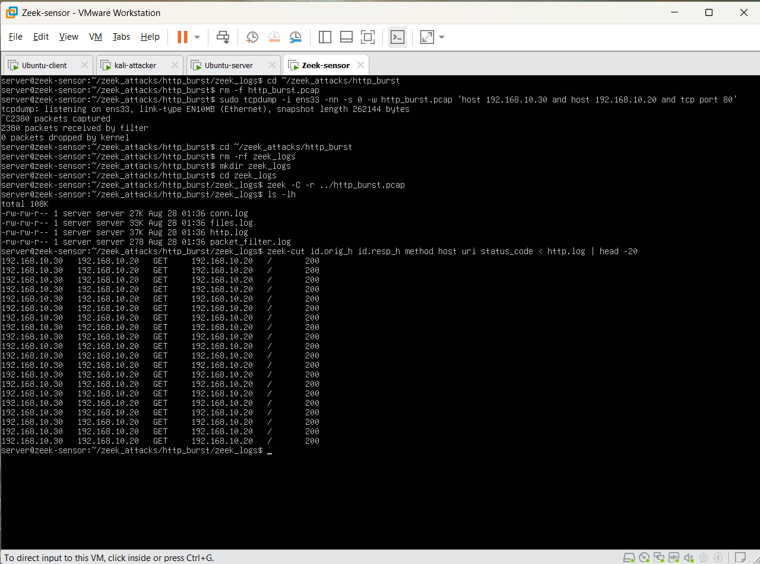
Figure 7.3. Internal HTTP-burst capture and Zeek http.log verification showing repeated HTTP GET requests from 192.168.10.30 to the controlled server.
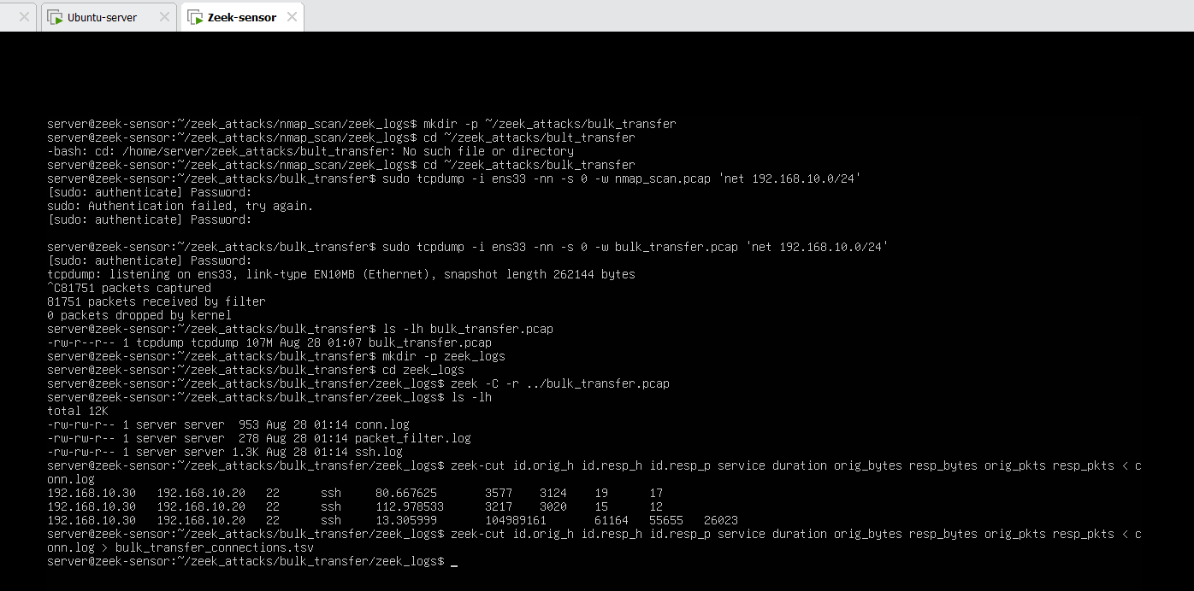
Figure 7.4. Bulk-transfer capture and Zeek connection evidence showing high-volume SSH traffic used as the exfiltration-like scenario.

8. Practical Dataset Construction and Raw Data Processing

8.1 Dataset Evolution:
The dataset was improved after the first successful capture instead of being treated as finished. The first combined internal and external dataset contained 3,047 records, but only 16 were normal. This was too small for reliable false-positive analysis. With only 16 normal records, one incorrect alert changed the FPR by 6.25 percentage points. In addition, an attack-heavy dataset could produce a strong-looking F1-score even when almost all normal records were flagged. For this reason, more capture sessions were added rather than keeping a dataset that was easy to use but weak for evaluation.
Table 8.1. Practical dataset evolution
Version / source | Total | Normal | Attack | Why it was added
Initial practical set: internal_gns3 | 3,047 | 16 | 3,031 | Early end-to-end test
external_laptop | 1,631 | 4 | 1,627 | Early end-to-end test
internal_gns3_v3 | 1,974 | 792 | 1,182 | Added much more normal traffic and more attack scenarios.
internal_gns3_v4 | 1,945 | 1,945 | 0 | Normal-only session used later to calculate target thresholds.
Final combined | 6,966 | 2,753 | 4,213 | Final dataset used for baseline testing; v4 was kept separate for recalibration and threshold-budget testing.
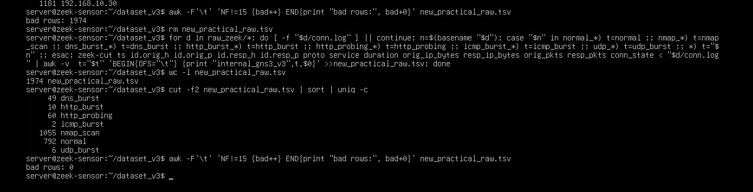
Figure 8.1. Validation of the internal_gns3_v3 raw dataset showing 1,974 rows, zero malformed rows and the scenario distribution including 792 normal records.

8.2 Raw TSV Schema and Metadata Separation
The raw practical dataset contains 15 columns. data_source and traffic_type are kept only for source tracking and evaluation. They are not used as model features. The remaining 13 network fields are used to create the features required for model testing.

Table 8.3. Raw practical TSV schema
Raw column | Meaning
data_source | Source of the traffic
traffic_type | Normal or attack scenario
ts | Connection time
id.orig_h | Source IP
id.orig_p | Source port
id.resp_h | Destination IP
id.resp_p | Destination port
proto | Protocol
service | Network service
duration | Connection duration
orig_ip_bytes | Bytes sent by source
resp_ip_bytes | Bytes sent by destination
orig_pkts | Packets sent by source
resp_pkts | Packets sent by destination
conn_state | Connection status

8.3 Cleaning and Standardization
Raw processing starts by checking that all required columns are present. The converter changes timestamps, ports, duration, byte counts and packet counts into numeric values. If a numeric value cannot be read, it is replaced with zero. Protocol text is trimmed and changed to lower case. Blank service values become ‘-’, blank protocol values become ‘other’, and blank connection states become ‘OTH’. Records are then ordered by scenario and timestamp so recent-connection features can be calculated in the same way each time.

The cleaning process is intentionally simple and careful. It does not create packet information that was never observed, and source-information fields are kept outside the model input. At the final portable-feature stage, any remaining NaN or positive/negative infinite numeric values are replaced with zero, and the output is checked to make sure every value is finite. This choice keeps the data compatible with the existing models.

8.4 Direct Flow Features
Ten continuous flow features are calculated directly from Zeek duration, packet counts and byte counts. If a formula requires division and the denominator is zero, the result is set to zero to avoid calculation errors. The formulas are included because they are part of the project-specific processing and allow another person to reproduce the feature converter without needing to inspect the notebook code.
- dur = duration
- spkts = orig_pkts, dpkts = resp_pkts
- sbytes = orig_ip_bytes, dbytes = resp_ip_bytes
- rate = (spkts + dpkts) / dur if dur > 0, otherwise 0
- sload = (8 × sbytes) / dur, dload = (8 × dbytes) / dur if dur > 0
- smean = sbytes / spkts if spkts > 0; dmean = dbytes / dpkts if dpkts > 0

8.5 Recent-Connection Behaviour Features
Seven count features describe recent connection behaviour. For each record, the converter looks at the current connection and up to 99 earlier connections within the same captured data_source and traffic_type group. This gives a maximum history window of 100 records.
Table 8.4. Recent connection features
Feature | Count within current + previous 99 records
ct_srv_src | Same service and same source IP.
ct_srv_dst | Same service and same destination IP.
ct_dst_ltm | Same destination IP.
ct_src_ltm | Same source IP.
ct_src_dport_ltm | Same source IP and destination port.
ct_dst_sport_ltm | Same destination IP and source port.
ct_dst_src_ltm | Same source/destination IP pair.

Traffic_type is a ground-truth scenario label. In this dataset it is used only to stop the rolling-history calculation from mixing records from different captured scenarios, and it is not given to the model as a feature. However, a real live network would not know the future scenario label in advance. Therefore, a production version should replace traffic_type with a neutral capture or session ID and process records in time order.

8.6 Protocol, Service and Zeek-to-UNSW State Mapping
Practical Zeek values must be mapped into the saved UNSW preprocessor-compatible categories. For protocol, tcp, udp and arp are kept, while any other protocol becomes another. Service values are copied after blank values are standardized. Zeek connection states need an approximate meaning-based mapping because Zeek and UNSW-NB15 use different state names. ICMP is mapped to ECO; Zeek SF to FIN; S1/S2/S3 to CON; S0/SH/SHR to REQ; selected reset and reject states to RST; and all other states to no.

Table 8.5. Zeek connection-state mapping
Zeek condition | Portable/UNSW-compatible state | Reason / note
proto == icmp | ECO | Represents echo-style ICMP; protocol itself later falls under `other` in the available protocol categories.
SF | FIN | Normal completed TCP-style connection approximation.
S1, S2, S3 | CON | Established/connected approximation.
S0, SH, SHR | REQ | Attempt/request without normal completion approximation.
REJ, RSTO, RSTR, RSTOS0, RSTRH | RST | Reject/reset family approximation.

This state mapping is only an approximation; it is not an exact one-to-one match in meaning. The mapping is needed because the experiment uses one fixed feature format across different datasets. Because of this, the mapping itself may reduce model performance and must be considered when explaining weak detection on some traffic types.

8.7 From 21 Portable Features to 41 Model-Ready Features
After the direct features, count features and categorical fields are created, the converter selects exactly 21 portable features. Eighteen are numeric and three are categorical: proto, service and state. The preprocessor that was previously fitted on UNSW data is then used only in transform mode. It is not fitted again on the GNS3 data. This creates the same 41-column numeric format expected by all six frozen models and keeps the practical experiment free from target-data fitting.
Table 8.6. Twenty-one portable features
Group | Features
Direct numeric (10) | dur, spkts, dpkts, sbytes, dbytes, rate, sload, dload, smean, dmean
Recent-count numeric (7) | ct_srv_src, ct_srv_dst, ct_dst_ltm, ct_src_ltm, ct_src_dport_ltm, ct_dst_sport_ltm, ct_dst_src_ltm
Same IP/port indicator (1) | is_sm_ips_ports
Categorical (3) | proto, service, state

The final 41 columns contain the 18 numeric or indicator features plus one-hot encoded categories for protocol, service and state. The feature order must remain fixed because the saved models expect the same column order they were trained in. Quality checks confirm that there are exactly 41 columns, that the feature and metadata files have the same number of rows, and that every numeric value is finite.

8.8 Labelling and Metadata
Binary labels are created after the scenario names are standardized. Normal is labelled 0, while every controlled attack or anomaly scenario is labelled 1. The metadata file keeps data_source, traffic_type, timestamp, source and destination IPs and ports, the binary label and kali_source. The kali_source value is 1 when the source IP matches either the internal Kali address (192.168.10.30) or the recorded external Kali address (192.168.4.52). This metadata is used for checking and for scenario/source analysis, but it is not passed to the detector.

8.9 Final Data-Quality Checks
Table 8.7. Dataset quality gates
Check | Final condition | Why this check matters
Row count | 6,966 rows in raw, metadata and 41-feature outputs. | Prevents features and labels from becoming misaligned.
Feature dimensionality | Exactly 41 model input columns. | Matches saved model/preprocessor contract.
Numerical validity | No NaN or ±∞ in the final model matrix. | Prevents silent model/scoring failures.
Label composition | 2,753 normals; 4,213 attacks. | Supports meaningful held-out FPR estimation.
Source source information | Four source/session labels kept. | Enables source-shift analysis.
Scenario source information | Nine final traffic types kept. | Enables scenario-level failure analysis.
No target refit | The saved source preprocessor only transformed GNS3 rows. | Keeps the cross-domain test fair by avoiding target-data fitting.

9. Model Integration and Evaluation Methodology

9.1 Frozen Model Integration
All six models are loaded from saved files and kept unchanged during practical testing. If model weights or hyperparameters were changed using the GNS3 data, the experiment would become target-domain adaptation, and it would no longer show whether the original trained models can generalize to a new environment. Every model receives the same 41-feature input and produces one anomaly score for each record. The score direction is made consistent across models so that a larger value always means more anomalous.

9.2 Anomaly Scores
Isolation Forest and LOF use scikit-learn score conventions where lower values indicate stronger abnormality, so the practical notebook multiplies those scores by -1. One-Class SVM uses the negative of its decision function. The Dense Autoencoder uses mean squared reconstruction error between the input and the reconstructed output. Deep SVDD uses the squared Euclidean distance between the network representation and the learned centre of normal data. These score definitions follow the related APIs and published anomaly-detection methods (Scikit-learn Developers, 2026a–c; TensorFlow, 2026; Ruff et al., 2018).
S_AE(x) = mean[(x − x_hat)^2]
S_DSVDD(x) = || φ(x) − c ||²

9.3 Hybrid IF+AE Fusion
Isolation Forest and Autoencoder scores use different numeric ranges. Before combining them, the Hybrid converts each score to a percentile based on the original UNSW normal validation-score distribution. For each target score, searchsorted(..., side="right")/(n+1) gives an estimated percentile. The two percentile scores are then combined using equal weights of 0.5 and 0.5.
S_Hybrid = 0.5 × S_IF(percentile) + 0.5 × S_AE(percentile)

9.4 Evaluation Metrics
- Precision shows how many alerts raised are actually attacks. = TP / (TP + FP)
- Recall shows how much of the attack traffic is detected. = TP / (TP + FN)
- F1 gives a single value that balances precision and recall. = 2 × Precision × Recall / (Precision + Recall)
- FPR is reported separately because it shows how often normal traffic creates unnecessary alerts. = FP / (FP + TN), False alerts per 1,000 normal records = 1,000 × FPR
- ROC-AUC and PR-AUC measure how well a model ranks attacks and normal traffic without choosing one fixed threshold (Sun, Sankararaman and Narayanaswamy, 2024).

9.5 Three-Stage Evaluation Design
Table 9.1. Three practical evaluation experiments
Stage | Question | Data and threshold rule
Experiment 1: frozen-source threshold baseline | Do the original UNSW-created from numeric cutoffs work on the final practical target domain? | All 6,966 practical records; frozen source thresholds; no target recalibration.
Experiment 2: 1% normal-only recalibration | Can false alerts be controlled better without changing model weights? | 1,945 v4 normal calibration records; held-out 5,021 test records; 99th-percentile normal score threshold.
Experiment 3: threshold-budget sweep | How sensitive is each model to a stricter or looser alert budget? | Same split; quantiles 99.5, 99, 98, 97, 95 and 90% corresponding to 0.5/1/2/3/5/10% budgets.

10. Three-Stage GNS3/Zeek Evaluation and Results

10.1 Experiment 1 — Frozen UNSW Thresholds on Final Practical v5
The first formal GNS3 experiment used the complete final v5 dataset containing 6,966 records. Each model was evaluated using its original threshold derived from the source-domain training data, without retraining or recalibration on the practical GNS3 traffic. Therefore, this experiment represents a strict cross-domain test in which the models were transferred directly from the benchmark environment to the practical network environment.
Of the 6,966 records, 4,213 were attack records, representing approximately 60.48% of the dataset. Because the test dataset is attack-heavy, the precision and F1 scores must be interpreted carefully. A detector that predicts almost every record as anomalous could still achieve precision close to the attack prevalence of approximately 0.605 and an F1 score around 0.75. Therefore, apparently high recall and F1 values do not necessarily indicate useful practical detection performance when the false-positive rate is also extremely high.
Table 10.1. Experiment 1 — Final v5 performance using frozen source-domain thresholds
Model | Precision | Recall | F1 | FPR | ROC-AUC | PR-AUC
Hybrid IF+AE | 0.6049 | 0.9964 | 0.7528 | 99.60% | 0.535 | 0.625
LOF | 0.6048 | 0.9962 | 0.7526 | 99.64% | 0.336 | 0.559
Dense AE | 0.6048 | 0.9950 | 0.7523 | 99.49% | 0.484 | 0.639
Deep SVDD | 0.6048 | 0.9945 | 0.7522 | 99.46% | 0.823 | 0.893
Isolation Forest | 0.6048 | 0.9926 | 0.7516 | 99.27% | 0.713 | 0.848
One-Class SVM | 0.6037 | 0.9862 | 0.7489 | 99.09% | 0.546 | 0.677

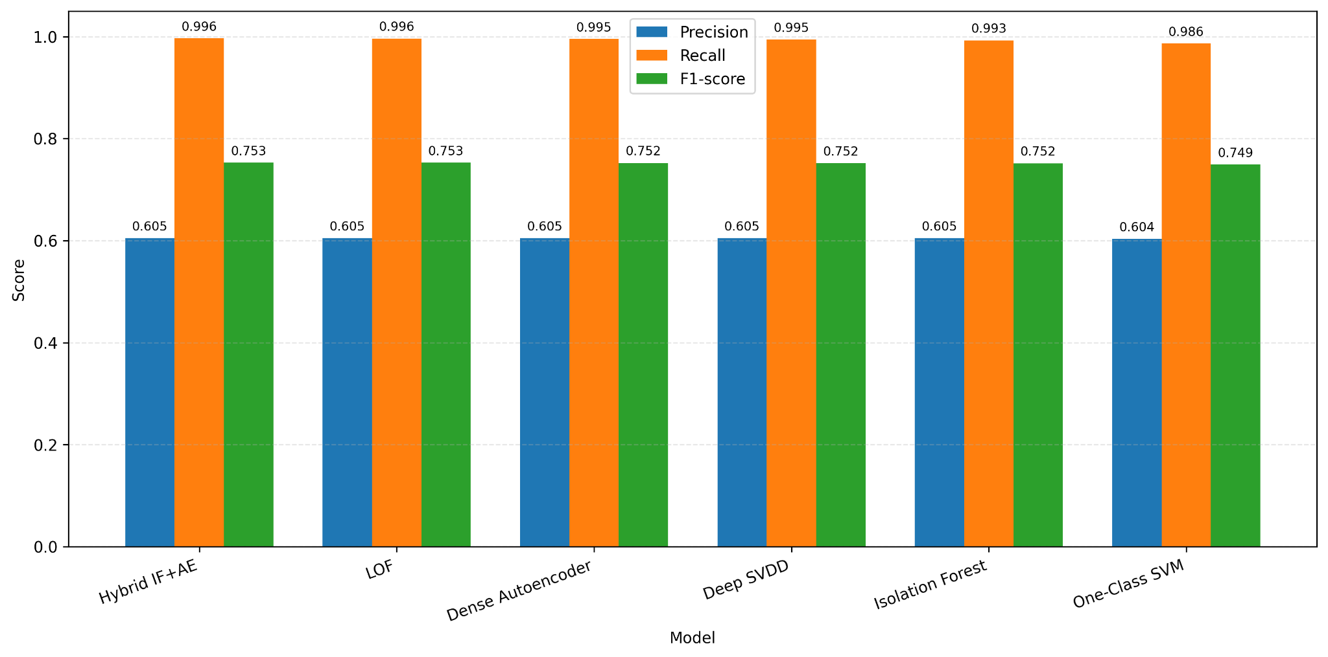
Figure 10.1. Precision, recall and F1 of the six models using frozen source-domain thresholds on the final practical v5 dataset (project-generated result).
At first glance, all six models appear to achieve very high recall, ranging from 98.62% to 99.64%, together with F1 scores of approximately 0.75. However, these results are misleading when considered without the false-positive rate. Every model incorrectly classified more than 99% of the normal practical traffic as anomalous. This means that the models were effectively treating almost the entire GNS3 dataset as attack traffic. Such behaviour would create an excessive number of false alarms and would not be suitable for the project's false-positive-aware intrusion detection objective.

Deep SVDD achieved the strongest ranking performance, with a ROC-AUC of 0.823 and PR-AUC of 0.893. Isolation Forest also retained useful discrimination, achieving a ROC-AUC of 0.713 and PR-AUC of 0.848. In comparison, LOF produced a ROC-AUC of only 0.336 and PR-AUC of 0.559, indicating much weaker separation between normal and attack records. The Hybrid model also showed limited ranking performance, with a ROC-AUC of 0.535 and PR-AUC of 0.625.

The very high false-positive rates were most likely caused by domain shift between UNSW-NB15 and the practical GNS3/Zeek environment. The two datasets contain different normal traffic patterns, protocol behaviour, connection characteristics and feature distributions. Because the original thresholds were learned from UNSW-NB15, normal GNS3 traffic could receive higher anomaly scores and therefore be incorrectly classified as attacks.

The result therefore indicates a threshold-transfer problem rather than complete model failure. Deep SVDD and Isolation Forest still retained useful ranking ability through their ROC-AUC and PR-AUC results, suggesting that the models could still separate normal and attack traffic to some extent. However, their original thresholds were not suitable for the new environment. This is why Experiment 2 recalibrates the thresholds using normal-only GNS3 traffic so that the decision boundary better matches the practical network.

10.2 Experiment 2 — GNS3 Normal-Only Threshold Recalibration
The second experiment keeps all model weights unchanged and changes only the decision threshold. All 1,945 records from internal_gns3_v4 are labelled normal and are used only for threshold calibration. The held-out test set contains every record that is not from v4: 5,021 records in total, with 808 normal and 4,213 attack records. The calibration and test sets do not overlap. Attack labels are not used to choose the thresholds; they are used only after threshold selection to measure performance. The reported frozen-threshold result also covers the full 6,966-record practical dataset, whereas recalibrated evaluation excludes the 1,945 normal-only v4 calibration records. Therefore, differences between the two published summaries cannot be attributed exclusively to changing the threshold; a like-for-like comparison must rescore the same 5,021 held-out records at both thresholds.
τ_1% = Q_0.99(S_normal,cal)
The threshold is calculated with NumPy's sample-quantile function (NumPy Developers, 2026). A 1% budget uses the 99th percentile of the calibration-normal scores. Any record with score >= threshold is treated as anomalous. The important point is that the 1% value describes the calibration-normal score distribution.
Table 10.2. Experiment 2 — held-out results at the 1% normal-only calibration budget
Model | Threshold | Precision | Recall | F1 | Held-out FPR | ROC-AUC | PR-AUC
Isolation Forest | 0.707030 | 0.9750 | 0.5922 | 0.7369 | 7.92% | 0.718 | 0.940
Hybrid IF+AE | 0.999903 | 0.8679 | 0.6347 | 0.7332 | 50.37% | 0.562 | 0.858
Deep SVDD | 0.003341 | 0.9865 | 0.2435 | 0.3906 | 1.73% | 0.831 | 0.959
Dense AE | 0.762572 | 0.8549 | 0.0909 | 0.1643 | 8.04% | 0.498 | 0.846
LOF | 9.962449 | 0.9751 | 0.0743 | 0.1381 | 0.99% | 0.406 | 0.826
One-Class SVM | 19.229768 | 0.8526 | 0.0631 | 0.1176 | 5.69% | 0.546 | 0.864

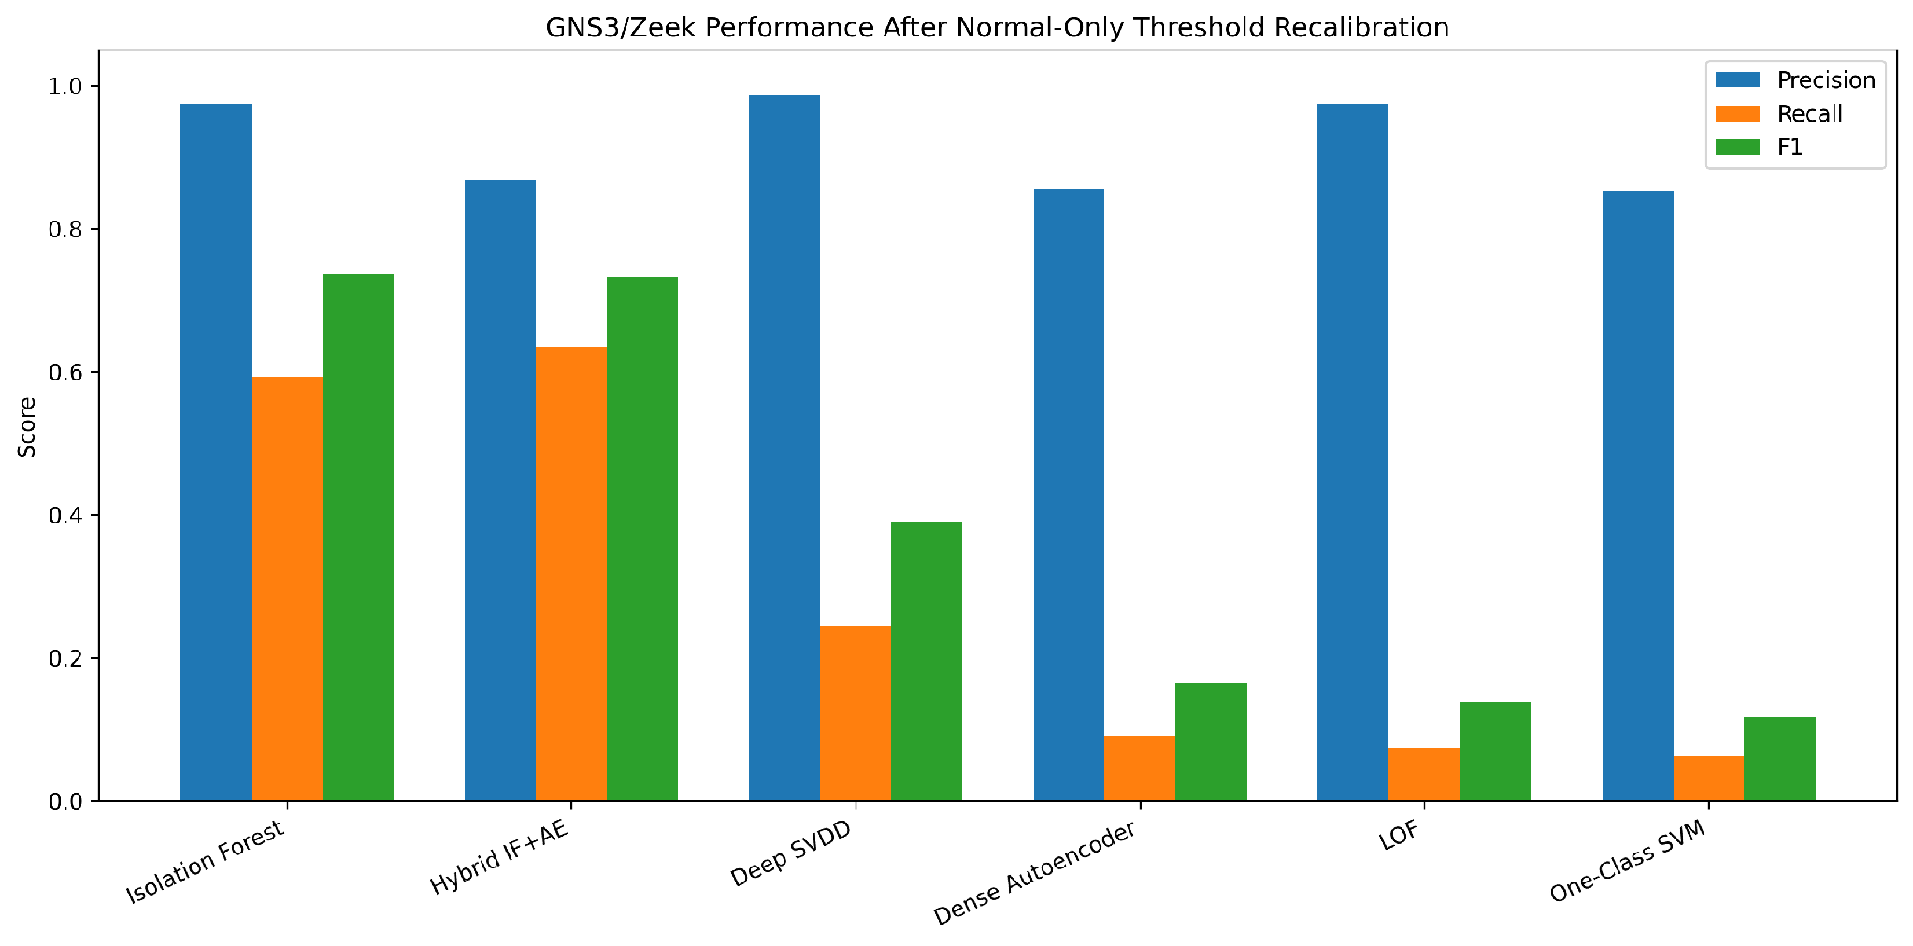
Figure 10.2. Precision, recall and F1 after 1% normal-only GNS3 threshold recalibration (project-generated result).
LOF produced the lowest false-positive rate, keeping the held-out FPR close to 1%. However, its recall was only 7.43%, which means it detected very few of the actual attacks. Therefore, LOF performed best only in terms of controlling false positives, but not in overall attack detection.

Deep SVDD also performed well when false-positive control is considered. It achieved a very low FPR of 1.73% and very high precision of 98.65%, meaning that most of the alerts it generated were correct. However, its recall was only 24.35%, so it still missed a large proportion of attacks. This shows that Deep SVDD is strong when the main goal is to minimize false alarms, but its strict threshold reduces its ability to detect attacks.

Isolation Forest provided a more balanced result. It detected 59.22% of attacks and maintained a high precision of 97.50%. However, its FPR increased to 7.92%, which is noticeably higher than LOF and Deep SVDD. Overall, the results show that there is no single model that performs best on every metric. LOF gives the strongest false-positive control but very poor attack detection. Deep SVDD also keeps false positives low and has excellent precision, but its recall remains limited.

10.3 Experiment 3 — Six-Budget Threshold Sensitivity
The third experiment keeps the same calibration and test split but calculates new thresholds at six normal-only budgets: 0.5%, 1%, 2%, 3%, 5% and 10%. These budgets use score quantiles of 0.995, 0.99, 0.98, 0.97, 0.95 and 0.90. Model weights remain unchanged, and attack labels are not used to choose the thresholds. The purpose is to measure how much extra attack detection is gained when the allowed alert rate on calibration-normal traffic becomes less strict.
Table 10.3. Experiment 3 threshold budgets
Budget | Quantile on calibration-normal score | Interpretation
0.5% | 0.995 | Very strict; only upper 0.5% of calibration-normal scores should cross, subject to ties.
1% | 0.990 | Strict reference operating point.
2% | 0.980 | Intermediate point added to resolve behaviour between 1% and 3%.
3% | 0.970 | Moderately relaxed; important transition for Deep SVDD.
5% | 0.950 | Higher alert tolerance.
10% | 0.900 | Exploratory high-alert point to expose recall ceiling/trade-off.

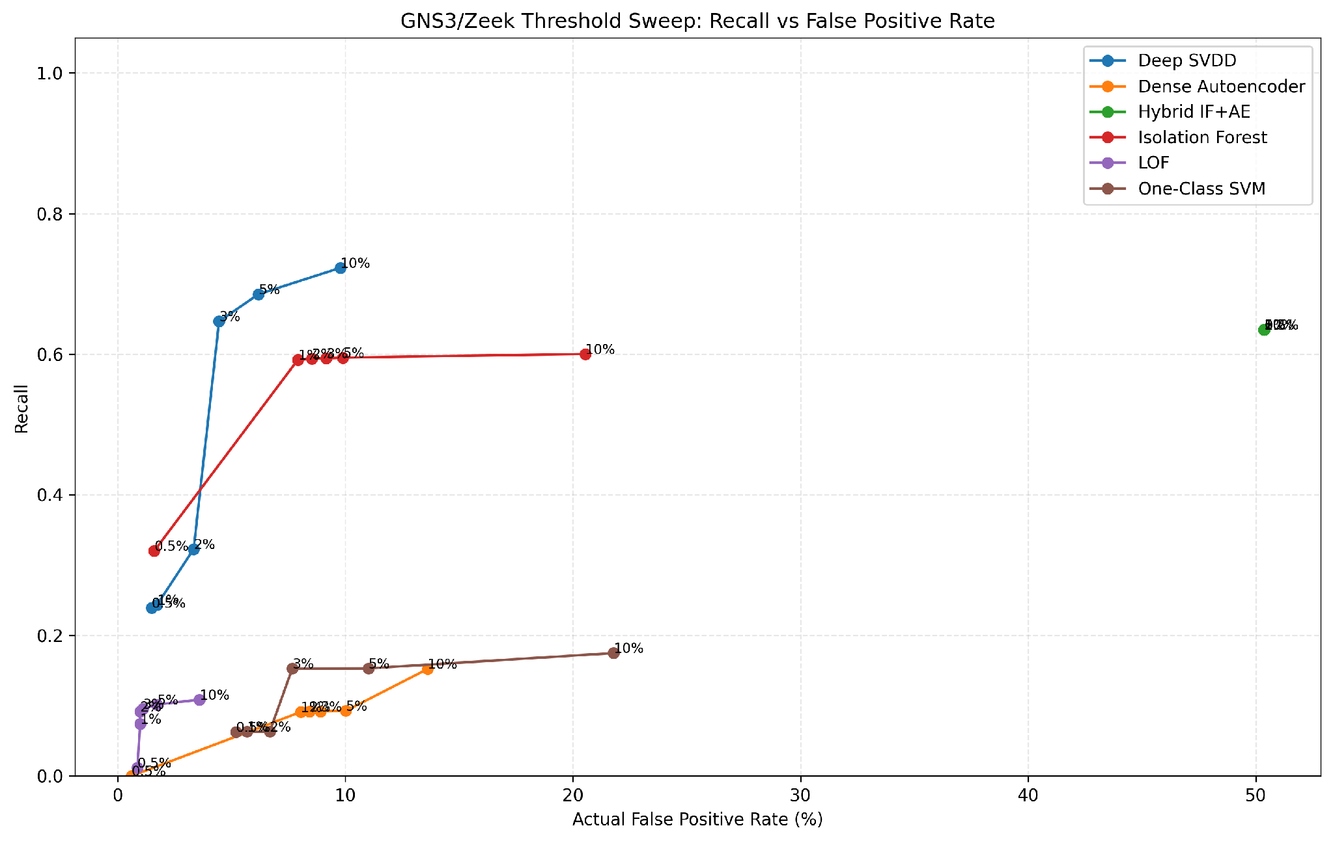
Figure 10.3. Recall compared with the actual held-out false-positive rate across the six calibration budgets (project-generated result).
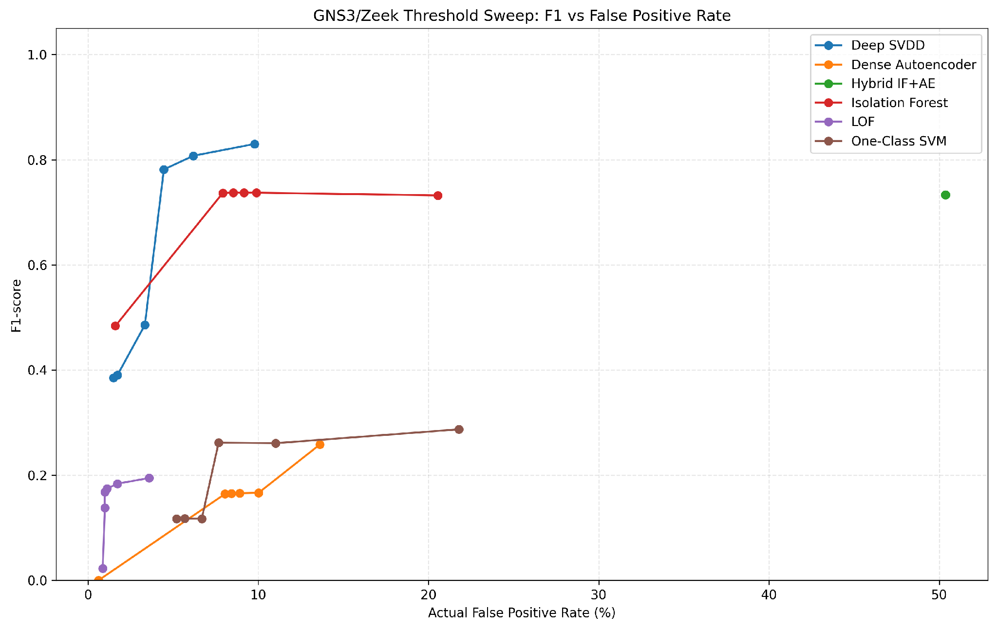
Figure 10.4. F1-score compared with the actual held-out false-positive rate across the six calibration budgets (project-generated result).
Table 10.4. Key threshold-sweep operating points for Deep SVDD and Isolation Forest
Model | Budget | Precision | Recall | F1 | Held-out FPR
Deep SVDD | 0.5% | 0.9882 | 0.2390 | 0.3849 | 1.49%
Deep SVDD | 1% | 0.9865 | 0.2435 | 0.3906 | 1.73%
Deep SVDD | 2% | 0.9805 | 0.3228 | 0.4857 | 3.34%
Deep SVDD | 3% | 0.9870 | 0.6468 | 0.7815 | 4.46%
Deep SVDD | 5% | 0.9830 | 0.6853 | 0.8076 | 6.19%
Deep SVDD | 10% | 0.9747 | 0.7228 | 0.8300 | 9.78%
Isolation Forest | 0.5% | 0.9905 | 0.3202 | 0.4839 | 1.61%
Isolation Forest | 1% | 0.9750 | 0.5922 | 0.7369 | 7.92%
Isolation Forest | 2% | 0.9732 | 0.5936 | 0.7374 | 8.54%
Isolation Forest | 3% | 0.9713 | 0.5941 | 0.7373 | 9.16%
Isolation Forest | 5% | 0.9691 | 0.5951 | 0.7374 | 9.90%
Isolation Forest | 10% | 0.9384 | 0.6003 | 0.7322 | 20.54%

Deep SVDD shows the clearest change across the threshold sweep. Moving from the 2% to the 3% calibration budget increases recall from 32.28% to 64.68%, while held-out FPR rises only from 3.34% to 4.46%. This suggests that many attack scores sit near this threshold area. The 3% point is therefore useful for practical discussion because it gives a large increase in attack detection for a relatively small increase in false alerts. This does not mean 3% is always the best threshold. Moving to 5% and 10% increases recall further, but each improvement becomes smaller compared with the extra false alerts.

Isolation Forest shows a different pattern. Recall rises sharply from 32.02% at the 0.5% budget to 59.22% at 1%, but after that it changes very little even when the budget reaches 10%. At the same time, held-out FPR keeps increasing and reaches 20.54% at 10%. This flat recall pattern means that making the threshold more relaxed after the first change mainly creates extra false alerts without finding many more attacks. Therefore, the same threshold budget should not be forced on every model.

The Hybrid shows the most important failure case. Its threshold is 0.9999026005649168 at every requested budget, and its precision, recall, F1 and FPR stay exactly the same: 86.79%, 63.47%, 0.7332 and 50.37%. The calibration check also shows an alert rate far above the requested budget. This happens because many Hybrid scores are tied at almost the same maximum percentile, and the rule uses `score >= threshold`. All records tied at that threshold are therefore alerted together. The result shows that changing the threshold alone cannot make the current Hybrid a reliable low-FPR detector. The score-normalisation method needs to be improved first.

10.4 Per-Traffic-Scenario Results at the 1% Reference Point
Testing each traffic type separately stops the large Nmap class from hiding poor performance on smaller scenarios. The rates below come from the held-out test after 1% recalibration. For the normal traffic category, the plotted rate is the false-positive rate, not an attack-detection rate.
Table 10.5. Scenario-level findings after 1% target-normal recalibration
Traffic type | Records | 1% reference behaviour | Interpretation
Nmap scan | 3,061 | IF 63.31%; Hybrid 64.82%; Deep 33.13%; AE 12.48%; LOF 8.92%; OC-SVM 0% | Strongest coverage for IF/Hybrid; OC-SVM misses this scenario.
DNS burst | 649 | Hybrid 78.12%; IF 60.09%; OC-SVM 14.33%; LOF 2.00%; Deep 0.31%; AE 0% | Hybrid rate must be read with its 50.37% normal FPR.
HTTP burst | 411 | Hybrid 44.53%; IF 40.63%; OC-SVM 40.15%; LOF 2.43%; Deep/AE 0% | Different models react to this pattern; no single detector dominates every scenario.
HTTP probing | 60 | All models 0% | Clear practical detection gap.
Failed SSH | 20 | LOF 85%; Deep 35%; OC-SVM 35%; IF/AE/Hybrid 0% | Interesting but sample size too small for stable claims.
ICMP burst | 3 | Deep 100%; AE 33.3%; OC-SVM 33.3%; others 0% | Report as 3/3, not as a general 100% guarantee.
UDP burst | 6 | All models 0% | Functional coverage exists, statistical evidence does not.
Bulk transfer | 3 | All models 0% | Very small set and a detection gap.
Normal | 808 | Hybrid 50.37%; AE 8.04%; IF 7.92%; OC-SVM 5.69%; Deep 1.73%; LOF 0.99% | This row measures false positives, not attack detection.

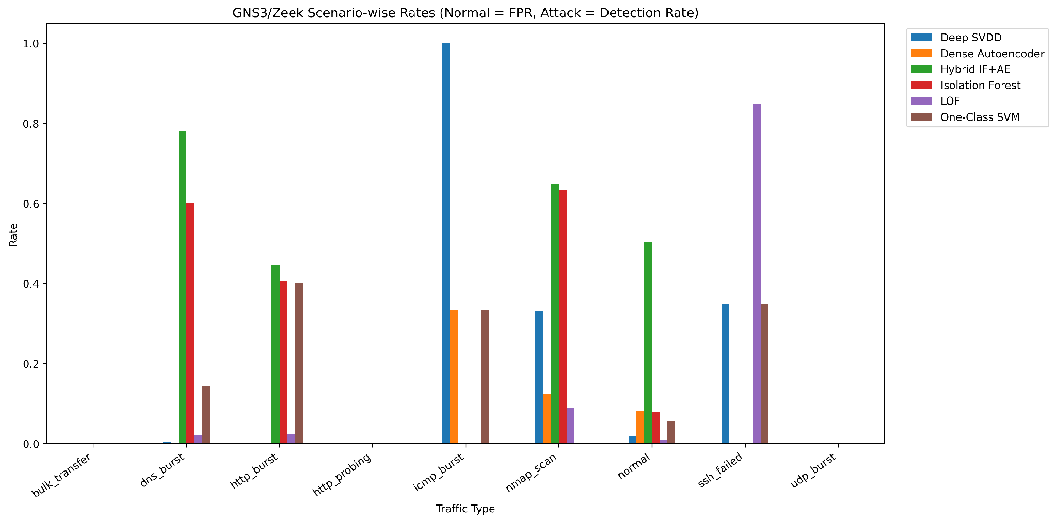
Figure 10.5. Per-scenario rate at the 1% recalibrated reference point (project-generated result). For normal traffic, the bar shows FPR. For attack traffic, it shows detection rate.

10.5 Source-Wise Results
Source-by-source analysis explains why a requested 1% calibration budget does not produce exactly 1% held-out FPR for every model. At the 1% point, Isolation Forest and Autoencoder each produce about 8.08% FPR on normal traffic, One-Class SVM 5.68% and Hybrid 51.39%. Deep SVDD is much closer at 1.52%, and LOF is 0.76%. This is a clear example of normal traffic changing between capture sessions.
Table 10.6. Source-wise held-out behaviour at 1% recalibration
Held-out source | Attack records | Normal records | Selected attack-detection result | Caution
internal_gns3 | 1,404 | 12 | IF 68.30%; Hybrid 77.85%; Deep 69.52% | Only 12 normal records; the source-level FPR is unstable.
external_laptop | 1,627 | 4 | IF 94.41%; Hybrid 95.08%; AE 23.29%; OC-SVM 16.35% | Normal denominator 4; do not work on new data source FPR.
internal_gns3_v3 | 1,182 | 792 | LOF 22.34%; Hybrid 2.88%; Deep 2.96%; IF/AE/OC-SVM ≈0% attack detection | This source contains almost all held-out normal records and shows the difference between calibration and test traffic.

11. Technical Findings, Verification and Quality Assurance

11.1 Why the Three Experiments Are Necessary Together
1Experiment 1 checks whether the original thresholds transfer to the practical network and shows that almost every normal record is above the source cutoff. Experiment 2 checks whether using normal traffic from the target environment can produce a more useful threshold without changing the trained model. Experiment 3 shows how each model changes when the allowed alert budget becomes stricter or more relaxed. Keeping all three experiments separate makes the cause of each result clearer. Improvements after recalibration can be linked to the decision threshold, while remaining problems point to the score distribution or feature representation.

11.2 False-Positive Behaviour as an Operational Constraint
In an SME, a high FPR means more unnecessary alerts for staff to review and can lead to alert fatigue. Experiment 1 shows how F1-score can hide this problem: F1 values around 0.75 may look acceptable, but about 99% of normal connections are incorrectly flagged. Experiment 2 shows the opposite problem: LOF keeps FPR close to 1% but detects only 7.43% of attacks. A useful threshold must therefore consider both attack detection and false alerts rather than improving only one metric.

11.3 Calibration Budget Is Not a Held-Out FPR Guarantee
A 1% calibration threshold is the 99th percentile of the calibration-normal scores. It is designed to control the calibration sample, although tied scores can still make the actual calibration alert rate slightly different. The FPR on the held-out test is a separate result measured on different normal traffic. Sun, Sankararaman and Narayanaswamy (2024) explain that choosing anomaly thresholds becomes difficult when data distributions change. The same issue appears in this artifact: a threshold that is strict on the v4 normal session can be much less strict when it is applied to v3 normal traffic.

11.4 Hybrid Score Saturation
The Hybrid using the same threshold from 0.5% to 10% is not a charting error. Its percentile normalisation uses the original UNSW validation scores, and many practical Isolation Forest and Autoencoder scores are mapped to almost the same maximum value. This creates a large group of identical Hybrid calibration scores near the threshold. Because the rule is `score >= threshold`, all records tied at that value are flagged together. The result is a calibration alert rate above 56% and a held-out FPR of 50.37%, even when a small budget is requested. This means that changing the target threshold alone cannot fix the current Hybrid score transformation.

11.5 Dataset and Feature-Engineering Validity Checks
- The raw data, metadata and model-input matrices were checked to make sure they contained the same number of rows before evaluation.
- The final model input was checked to make sure it contained exactly 41 features in the required order.
- NaN and infinite values were removed or replaced before scoring, and the final matrix was checked to make sure all values were finite.
- The calibration set contains 1,945 records and all are labelled normal. The held-out test contains 5,021 records, and there is no overlap between the two sets. Here, no overlap means that the calibration and evaluation arrays contain disjoint row indices; the notebook does not demonstrate a content-hash audit proving that no equivalent network flows occur in both capture sessions.
- Confusion-matrix totals were checked against the full held-out sample count so the metric tables could not accidentally leave out records.
- Scenario and source masks were built from `metadata_test`, not from the full 6,966-row metadata file. An indexing error revealed this requirement, and the correction is documented because debugging and verification are part of the technical work.
- The threshold-sweep output was checked to contain exactly 36 rows: 6 models × 6 budgets. This provides a simple completeness check.

12. Ethical, Legal and Professional Considerations

12.1 Authorised Attack Simulation
Nmap scanning, failed-login attempts, burst traffic and exfiltration-like transfers can be valid security tests or harmful actions depending on the target and whether permission has been given. This artefact manages that risk by sending attack traffic only to project-controlled lab systems and keeping the attack network isolated. Commands, screenshots and logs should be saved as evidence of the work, but the report should not expose passwords, tokens or unrelated host information.

12.2 Privacy and Data Minimization
PCAP files and network logs may contain IP addresses, ports, hostnames, URLs, usernames and timing details. In a real environment, some of this information could be personal or sensitive. This project mainly uses experimental traffic control, which greatly reduces that risk. If the same method were used in an Australian organization, APP 11 requires reasonable technical and organizational steps to protect personal information and to destroy or de-identify it when it is no longer needed, unless a legal exception applies (OAIC, 2025). A real deployment should therefore limit access to raw PCAP files, keep data only as long as necessary, separate research data from operational dashboards and record who is allowed to export detailed logs.

12.3 Professional Integrity and Transparent Reporting
The ACS Code of Professional Ethics is based on honesty, trustworthiness and respect (ACS, 2023; ACS, 2024). These values have direct meaning in this artefact. Honesty means reporting the Hybrid saturation problem, missed HTTP-probing, UDP and bulk-transfer scenarios, and the calibration-source mismatch instead of showing only favorable results. Trustworthiness means keeping raw evidence, not creating fake screenshots or results, and clearly stating where the models and code come from. Respect means avoiding unauthorized testing and collecting only the network data needed for the experiment.

12.4 Intellectual Property and Code Attribution
No external algorithm or software library is presented as original work. The original algorithm papers, official APIs and reference implementations are cited in Table 4.1 and in the reference list. The project-specific code covers the practical integration work: merging and cleaning the dataset, mapping fields, creating features, applying the saved preprocessor, putting model scores in a common direction, calibrating thresholds, calculating metrics, separating results by scenario and source, and packaging the outputs.

12.5 Human Oversight and Decision Risk
An anomaly score shows that traffic is unusual; it does not prove that the traffic is malicious. Automatic blocking would not be suitable for the current system because some models still produce many false positives and some attack types are missing. A safer use is decision support: flag unusual connections, keep the related Zeek context and let a human analyst or a stronger correlation rule investigate. If automated blocking is added later, it should include severity and context checks, a way to reverse actions, and monitoring for changes in threshold behavior over time.

13. Limitations, Risks and Recommendations

13.1 Technical Limitations
Table 13.1. Technical limitations and corrective actions
Limitation | How it affects the result | Recommended improvement
v4-only normal calibration | Held-out normals are mostly v3; Held-out FPR can become much higher even when the calibration budget is calculated correctly. | Collect representative normal calibration across multiple sessions/sources and keep separate test portions.
Low-count attack scenarios | 3–20 records make rates unstable and highly discrete. | Repeat bulk/ICMP/UDP/failed-SSH scenarios across multiple independent sessions.
Scenario-scoped rolling counts | Grouping recent counts by `traffic_type` uses a ground-truth-created from session boundary. | Replace with neutral capture/session IDs and process chronologically in future/live pipeline.
Approximate Zeek→UNSW state mapping | Semantic mismatch can distort feature meaning. | Validate mappings measuredly; consider a representation trained directly on Zeek semantics.
Hybrid percentile saturation | Budgets collapse to identical threshold; FPR cannot be controlled. | Normalise component scores against target-normal calibration or redesign fusion, tested as a separate experiment.
Offline batch evaluation | Does not measure real-time latency, throughput or alert workflow. | Prototype streaming Zeek ingestion and measure end-to-end latency/resource use.
Attack-heavy final set | Useful for attack analysis but not representative of real SME prevalence. | Use FPR/false alerts per 1,000 and evaluate on longer mostly-normal practical traces.

13.2 Future Experiment: Representative Normal Calibration
The most useful next robustness test is to build a normal-only calibration set from several practical sources or sessions instead of using only v4. A clear design would take a fixed percentage of normal records from each source for calibration, keep all attack records out of calibration, test on the remaining normal records plus all attacks, and repeat the split with several random seeds. Reporting the mean and standard deviation of FPR and recall would show whether the threshold method is stable or depends heavily on one favourable calibration session. The current v4-only experiment should still remain in the report because it provides real evidence of session-to-session change.

14. Conclusion
This individual artefact covers the full practical path from controlled network traffic to anomaly-detection testing. An isolated GNS3/VMware lab was monitored with Zeek. Normal and attack or anomaly scenarios were generated from internal and external practical sources, and Zeek logs and PCAP evidence were saved. The dataset was improved from an attack-heavy pilot of 3,047 records to a final collection of 6,966 records containing 2,753 normal records. Raw Zeek fields were cleaned, converted into 21 portable features and then transformed, without refitting on the target data, into the exact 41-feature format expected by the six frozen UNSW-trained models.
The three testing stages provide much more information than one model-comparison table. Using the original source thresholds produced false-positive rates of about 99% on practical normal traffic. Normal-only recalibration showed that changing the threshold for the target environment can make some models more usable, while also revealing differences between capture sessions. The six-budget sweep then showed that each model responds differently to threshold changes. Deep SVDD has a strong increase in recall around the 3% calibration budget. Isolation Forest changes little after its 1% transition. The Hybrid cannot be controlled properly because its percentile-normalised score becomes saturated. The scenario results also show that the models do not detect every traffic type equally and that scenarios with very small sample sizes need to be repeated before strong conclusions are made.
The final contribution is therefore a repeatable practical evaluation method, not a claim that the system provides perfect intrusion detection. The work shows why it is important to keep clear source information, collect varied normal traffic, maintain compatible features, separate calibration from testing, measure false positives directly and report failure cases openly when moving an unsupervised NIDS from a benchmark dataset to a different network environment. These practices support the expected level of technical depth, critical evaluation and professional responsibility for the project.

15. References
Australian Computer Society (ACS) (2023) Code of Professional Ethics. Available at: https://www.acs.org.au/governance/rules-and-regulations.html (Accessed: 2 October 2026).
Australian Computer Society (ACS) (2024) 'New ACS Code of Professional Ethics', Information Age, 31 January. Available at: https://ia.acs.org.au/article/2024/new-acs-code-of-professional-ethics-.html (Accessed: 2 October 2026).
Bagui, S.S., Mink, D., Bagui, S.C., Ghosh, T., Plenkers, R., McElroy, T., Dulaney, S. and Shabanali, S. (2023) 'Introducing UWF-ZeekData22: A Comprehensive Network Traffic Dataset Based on the MITRE ATT&CK Framework', Data, 8(1), 18. https://doi.org/10.3390/data8010018.
Borgioli, N., Aromolo, F., Phan, L.T.X. and Buttazzo, G.C. (2024) 'A convolutional autoencoder architecture for robust network intrusion detection in embedded systems', Journal of Systems Architecture, 156, 103283. https://doi.org/10.1016/j.sysarc.2024.103283.
Breunig, M.M., Kriegel, H.-P., Ng, R.T. and Sander, J. (2000) 'LOF: Identifying density-based local outliers', Proceedings of the 2000 ACM SIGMOD International Conference on Management of Data, pp. 93–104.
Dragoi, M., Burceanu, E., Haller, E., Manolache, A. and Brad, F. (2022) 'AnoShift: A Distribution Shift Benchmark for Unsupervised Anomaly Detection', Advances in Neural Information Processing Systems, 35. https://doi.org/10.52202/068431-2381.
GNS3 (2026a) Getting Started with GNS3. Available at: https://docs.gns3.com/docs (Accessed: 2 October 2026).
GNS3 (2026b) Adding VMware VMs to GNS3 Topologies. Available at: https://docs.gns3.com/docs/emulators/adding-vmware-vms-to-gns3-topologies (Accessed: 2 October 2026).
Goldschmidt, P. and Chudá, D. (2025) 'Network intrusion datasets: A survey, limitations, and recommendations', Computers & Security, 156, 104510. https://doi.org/10.1016/j.cose.2025.104510.
Lanfer, E., Brockmann, D. and Aschenbruck, N. (2025) 'Technical Report: Generating the WEB-IDS23 Dataset', arXiv:2502.03909.
Layeghy, S., Baktashmotlagh, M. and Portmann, M. (2023) 'DI-NIDS: Domain invariant network intrusion detection system', Knowledge-Based Systems, 273, 110626. https://doi.org/10.1016/j.knosys.2023.110626.
Layeghy, S., Gallagher, M. and Portmann, M. (2024) 'Benchmarking the benchmark — Comparing synthetic and real-world Network IDS datasets', Journal of Information Security and Applications, 80, 103689. https://doi.org/10.1016/j.jisa.2023.103689.
Layeghy, S. and Portmann, M. (2023) 'Explainable cross-domain evaluation of ML-based network intrusion detection systems', Computers & Electrical Engineering, 108, 108692. https://doi.org/10.1016/j.compeleceng.2023.108692.
Liu, F.T., Ting, K.M. and Zhou, Z.-H. (2008) 'Isolation Forest', 2008 Eighth IEEE International Conference on Data Mining, pp. 413–422.
Moomtaheen, F., Bagui, S.S., Bagui, S.C. and Mink, D. (2024) 'Extended Isolation Forest for Intrusion Detection in Zeek Data', Information, 15(7), 404. https://doi.org/10.3390/info15070404.
NumPy Developers (2026) numpy.quantile documentation. Available at: https://numpy.org/doc/stable/reference/generated/numpy.quantile.html (Accessed: 2 October 2026).
Office of the Australian Information Commissioner (OAIC) (2025) Chapter 11: APP 11 — Security of personal information. Updated 3 October 2025. Available at: https://www.oaic.gov.au/privacy/australian-privacy-principles/australian-privacy-principles-guidelines/chapter-11-app-11-security-of-personal-information (Accessed: 2 October 2026).
Pinto, D., Amorim, I., Maia, E. and Praça, I. (2025) 'A review on intrusion detection datasets: tools, processes, and features', Computer Networks, 262, 111177. https://doi.org/10.1016/j.comnet.2025.111177.
PyTorch (2026) torch.nn.Module documentation. Available at: https://docs.pytorch.org/docs/stable/generated/torch.nn.Module.html (Accessed: 2 October 2026).
Ruff, L., Vandermeulen, R.A., Görnitz, N., Deecke, L., Siddiqui, S.A., Binder, A., Müller, E. and Kloft, M. (2018) 'Deep One-Class Classification', Proceedings of the 35th International Conference on Machine Learning, PMLR 80, pp. 4393–4402.
Ruff, L. et al. (n.d.) Deep-SVDD-PyTorch: A PyTorch implementation of the Deep SVDD anomaly detection method. Available at: https://github.com/lukasruff/Deep-SVDD-PyTorch (Accessed: 2 October 2026).
Schölkopf, B., Platt, J.C., Shawe-Taylor, J., Smola, A.J. and Williamson, R.C. (2001) 'Estimating the support of a high-dimensional distribution', Neural Computation, 13(7), pp. 1443–1471.
Scikit-learn Developers (2026a) IsolationForest documentation. Available at: https://scikit-learn.org/stable/modules/generated/sklearn.ensemble.IsolationForest.html (Accessed: 2 October 2026).
Scikit-learn Developers (2026b) LocalOutlierFactor documentation. Available at: https://scikit-learn.org/stable/modules/generated/sklearn.neighbors.LocalOutlierFactor.html (Accessed: 2 October 2026).
Scikit-learn Developers (2026c) OneClassSVM documentation. Available at: https://scikit-learn.org/stable/modules/generated/sklearn.svm.OneClassSVM.html (Accessed: 2 October 2026).
Sun, S.H., Sankararaman, A. and Narayanaswamy, B.M. (2024) 'Online Adaptive Anomaly Thresholding with Confidence Sequences', Proceedings of the 41st International Conference on Machine Learning, PMLR 235, pp. 47105–47132.
TensorFlow (2026) Intro to Autoencoders — anomaly detection. Available at: https://www.tensorflow.org/tutorials/generative/autoencoder (Accessed: 2 October 2026).
University of New Brunswick Canadian Institute for Cybersecurity (UNB CIC) (2026) CICFlowMeter. Available at: https://www.unb.ca/cic/research/applications.html (Accessed: 2 October 2026).
Zeek Project (2026a) Quick Start Guide — Book of Zeek. Available at: https://docs.zeek.org/en/v8.2.1/quickstart.html (Accessed: 2 October 2026).
Zeek Project (2026b) Common Logs — Book of Zeek. Available at: https://docs.zeek.org/en/current/reference/logs/index.html (Accessed: 2 October 2026).
Zeek Project (2026c) conn.log — Book of Zeek. Available at: https://docs.zeek.org/en/master/reference/logs/conn.html (Accessed: 2 October 2026).

16. Appendices

Appendix A. Exact Final Dataset Composition
Table A1. Final v5 traffic-type distribution
Traffic type | Records | Class
normal | 2,753 | Normal
nmap_scan | 3,061 | Attack
dns_burst | 649 | Attack
http_burst | 411 | Attack
http_probing | 60 | Attack
ssh_failed | 20 | Attack
udp_burst | 6 | Attack
bulk_transfer | 3 | Attack
icmp_burst | 3 | Attack

Appendix B. Exact 41-Feature Model Input
Table B1. Fixed 41-feature order expected by the frozen models
Feature | Feature | Feature | Feature
1. dur | 2. spkts | 3. dpkts | 4. sbytes
5. dbytes | 6. rate | 7. sload | 8. dload
9. smean | 10. dmean | 11. ct_srv_src | 12. ct_srv_dst
13. ct_dst_ltm | 14. ct_src_ltm | 15. ct_src_dport_ltm | 16. ct_dst_sport_ltm
17. ct_dst_src_ltm | 18. is_sm_ips_ports | 19. proto_arp | 20. proto_other
21. proto_tcp | 22. proto_udp | 23. service_- | 24. service_dns
25. service_ftp | 26. service_ftp-data | 27. service_http | 28. service_pop3
29. service_radius | 30. service_smtp | 31. service_snmp | 32. service_ssh
33. state_CON | 34. state_ECO | 35. state_FIN | 36. state_INT
37. state_PAR | 38. state_REQ | 39. state_RST | 40. state_URN
41. state_no

Appendix C. Full GNS3 Threshold-Budget Sweep
Table C1. Complete 36-row GNS3/Zeek threshold sweep (held-out test)
Model | Budget | Preci | Recall | F1 | FPR | ROC-AUC | PR-AUC
Deep SVDD | 0.5% | 0.988 | 0.239 | 0.385 | 1.49% | 0.831 | 0.959
Deep SVDD | 1% | 0.987 | 0.244 | 0.391 | 1.73% | 0.831 | 0.959
Deep SVDD | 2% | 0.981 | 0.323 | 0.486 | 3.34% | 0.831 | 0.959
Deep SVDD | 3% | 0.987 | 0.647 | 0.781 | 4.46% | 0.831 | 0.959
Deep SVDD | 5% | 0.983 | 0.685 | 0.808 | 6.19% | 0.831 | 0.959
Deep SVDD | 10% | 0.975 | 0.723 | 0.830 | 9.78% | 0.831 | 0.959
Dense Autoencoder | 0.5% | 0.000 | 0.000 | 0.000 | 0.62% | 0.498 | 0.846
Dense Autoencoder | 1% | 0.855 | 0.091 | 0.164 | 8.04% | 0.498 | 0.846
Dense Autoencoder | 2% | 0.850 | 0.092 | 0.165 | 8.42% | 0.498 | 0.846
Dense Autoencoder | 3% | 0.843 | 0.092 | 0.166 | 8.91% | 0.498 | 0.846
Dense Autoencoder | 5% | 0.828 | 0.093 | 0.167 | 10.02% | 0.498 | 0.846
Dense Autoencoder | 10% | 0.854 | 0.152 | 0.258 | 13.61% | 0.498 | 0.846
Hybrid IF+AE | 0.5% | 0.868 | 0.635 | 0.733 | 50.37% | 0.562 | 0.858
Hybrid IF+AE | 1% | 0.868 | 0.635 | 0.733 | 50.37% | 0.562 | 0.858
Hybrid IF+AE | 2% | 0.868 | 0.635 | 0.733 | 50.37% | 0.562 | 0.858
Hybrid IF+AE | 3% | 0.868 | 0.635 | 0.733 | 50.37% | 0.562 | 0.858
Hybrid IF+AE | 5% | 0.868 | 0.635 | 0.733 | 50.37% | 0.562 | 0.858
Hybrid IF+AE | 10% | 0.868 | 0.635 | 0.733 | 50.37% | 0.562 | 0.858
Isolation Forest | 0.5% | 0.990 | 0.320 | 0.484 | 1.61% | 0.718 | 0.940
Isolation Forest | 1% | 0.975 | 0.592 | 0.737 | 7.92% | 0.718 | 0.940
Isolation Forest | 2% | 0.973 | 0.594 | 0.737 | 8.54% | 0.718 | 0.940
Isolation Forest | 3% | 0.971 | 0.594 | 0.737 | 9.16% | 0.718 | 0.940
Isolation Forest | 5% | 0.969 | 0.595 | 0.737 | 9.90% | 0.718 | 0.940
Isolation Forest | 10% | 0.938 | 0.600 | 0.732 | 20.54% | 0.718 | 0.940
LOF | 0.5% | 0.875 | 0.012 | 0.023 | 0.87% | 0.406 | 0.826
LOF | 1% | 0.975 | 0.074 | 0.138 | 0.99% | 0.406 | 0.826
LOF | 2% | 0.980 | 0.092 | 0.168 | 0.99% | 0.406 | 0.826
LOF | 3% | 0.978 | 0.096 | 0.174 | 1.11% | 0.406 | 0.826
LOF | 5% | 0.968 | 0.102 | 0.184 | 1.73% | 0.406 | 0.826
LOF | 10% | 0.940 | 0.108 | 0.195 | 3.59% | 0.406 | 0.826
One-Class SVM | 0.5% | 0.863 | 0.063 | 0.117 | 5.20% | 0.546 | 0.864
One-Class SVM | 1% | 0.853 | 0.063 | 0.118 | 5.69% | 0.546 | 0.864
One-Class SVM | 2% | 0.831 | 0.063 | 0.117 | 6.68% | 0.546 | 0.864
One-Class SVM | 3% | 0.912 | 0.153 | 0.262 | 7.67% | 0.546 | 0.864
One-Class SVM | 5% | 0.879 | 0.153 | 0.261 | 11.01% | 0.546 | 0.864
One-Class SVM | 10% | 0.807 | 0.175 | 0.287 | 21.78% | 0.546 | 0.864

Appendix D. Screenshot and Evidence Placement Register
Table D1. Evidence placement plan
Report location | Screenshot filename | What the screenshot should show
Section 5.1 | final_connecting_from_gns3.png | GNS3 topology / VMs connected to the lab network.
Section 5.2 | client_ip__addres.png | Ubuntu client address configuration.
Section 5.2 | pinging_client_to_server.png | Client-to-server reachability before capture.
Section 6.1 | server_cofig_for_normaldata.png | Server service configuration for normal traffic.
Section 7.2 DNS | server_config_for_dns_data.png | DNS service configuration.
Section 7.2 DNS | dns_working_in_client.png | Successful DNS traffic from the client.
Section 7.2 SSH | client_ssh_data_generate.png | Normal SSH traffic generation.
Section 6.3 | zeek_install_version.png | Zeek installation/version evidence.
Section 6.3 | zeek_ip.png | Zeek sensor network/interface evidence.
Section 6.3 | zeek_capturing_packets.png | Live Zeek packet capture.
Section 6.3 | capturing_data_log_file.png | Zeek log-file creation.
Section 6.3/6.4 | data_checking.png | Log content verification after known traffic.
Section 6.4 | mount_logs.png | Mounted/archived log evidence.
Section 5.3 external path | server_connection(2).png | External-to-lab return route and captured ICMP from 192.168.4.52.
Section 5.3 external path | processing_raw_data(2).png | Separate external PCAP processing into scenario-specific Zeek logs.
Section 7.3 | 02_http_burst_zeek_capture(1).png | HTTP-burst packet capture and repeated HTTP request evidence.
Section 7.3 | 05_bulk_transfer_zeek_capture(1).png | Bulk-transfer PCAP and Zeek connection evidence.
Section 8.1 | stracture.png | v3 raw-dataset row validation and scenario counts.

Appendix E. Artefact Output Files
Table E1. Reproducible individual artefact outputs
Artefact | Purpose
combined_practical_traffic_v5_raw.tsv | 15-column raw practical traffic plus source information.
combined_practical_traffic_v5_metadata.csv | Source/scenario/endpoints/label metadata for evaluation.
combined_practical_traffic_v5_41_features.csv | Final 6,966×41 numerical input for frozen models.
input_converter.ipynb | Raw cleaning, 21-feature engineering, state/protocol mapping and saved-preprocessor transform.
GNS3_Zeek_Testing_Results.zip | Experiment 1 frozen-threshold baseline result package.
GNS3_Zeek_Recalibrated_Results.zip | Experiment 2 normal-only threshold recalibration package.
GNS3_Zeek_Threshold_Budget_Sweep_Results.zip | Experiment 3 six-budget sensitivity result package.
Threshold JSON / CSV/XLSX / PNG charts | Machine-readable thresholds, metrics and figures for audit/reproduction.

